**NATIONAL UNIVERSITY OF SCIENCES & TECHNOLOGY**

**MILTARY COLLEGE OF SIGNALS, NUST**



Object Oriented Programming (OOP)

(CS-212)

* **Submitted by:** MUHAMMAD AHMAD SULTAN
* RANK: NC o CMS ID: 408709
* COURSE: BESE-28 o SECTION: C
* DEPARTMENT:  **COMPUTER SOFTWARE**

**ENGINEERING** (CSE)

* Submitted to: LE Muhammad Asif
* DATED: **13-05-2023**

**OPEN ENDED LAB**

***MILTARY COLLEGE OF SIGNALS***

* *STUDENT MANAGEMENT SYSTEM*

**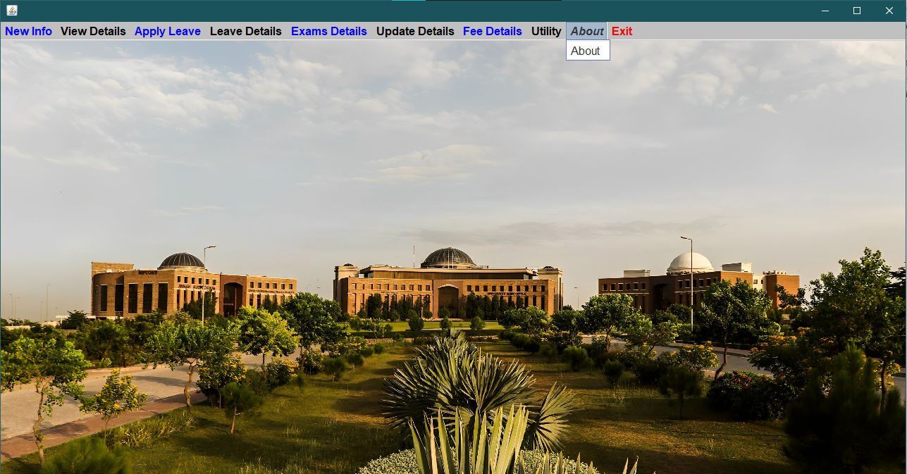***(MCS-SMS)*

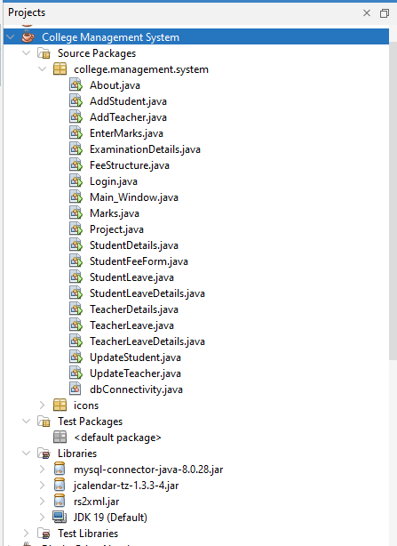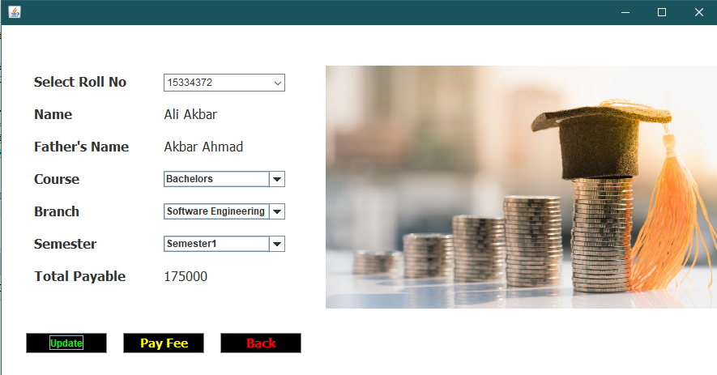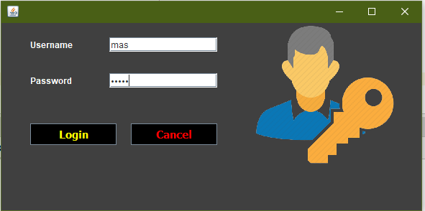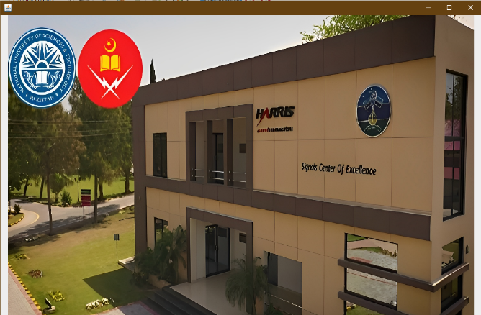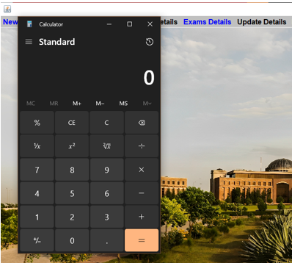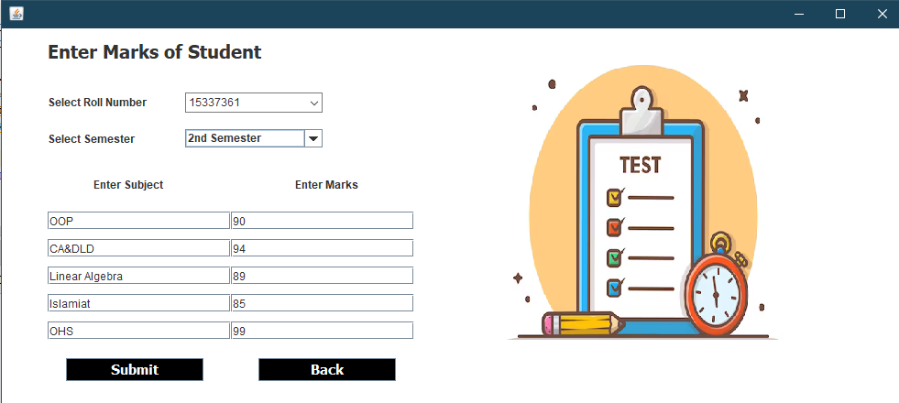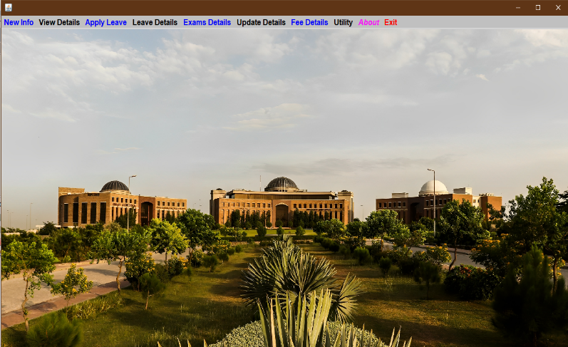

* **Program Code for Main Window**

package college.management.system;

/**

*

* @author Muhammad Ahmad Sultan

*/

import javax.swing.*;

import java.awt.*;

public class Main_Window extends JFrame implements Runnable {

Thread t;

Main_Window () {

ImageIcon i1 = new ImageIcon(ClassLoader.getSystemResource("icons/mcs@img.png"));

Image i2 = i1.getImage().getScaledInstance(1000, 700, Image.SCALE_DEFAULT);

ImageIcon i3 = new ImageIcon(i2);

JLabel image = new JLabel(i3);

add(image);

t = new Thread(this);

t.start();

setVisible(true);

int x = 1;

for (int i = 2; i <= 600; i+=4, x+=1) {

setLocation(600 - ((i + x)/2), 350 - (i/2));

setSize(i + 3*x, i + x/2);

try {

Thread.sleep(10);

} catch (Exception e) {}

}

}

public void run() {

try {

Thread.sleep(7000);

setVisible(false);

// Next Frame

new Login();

} catch (Exception e) {

}

}

public static void main(String[] args) {

new Main_Window();

}

}

* **OUTPUT (ScreenShot) for Main Window**

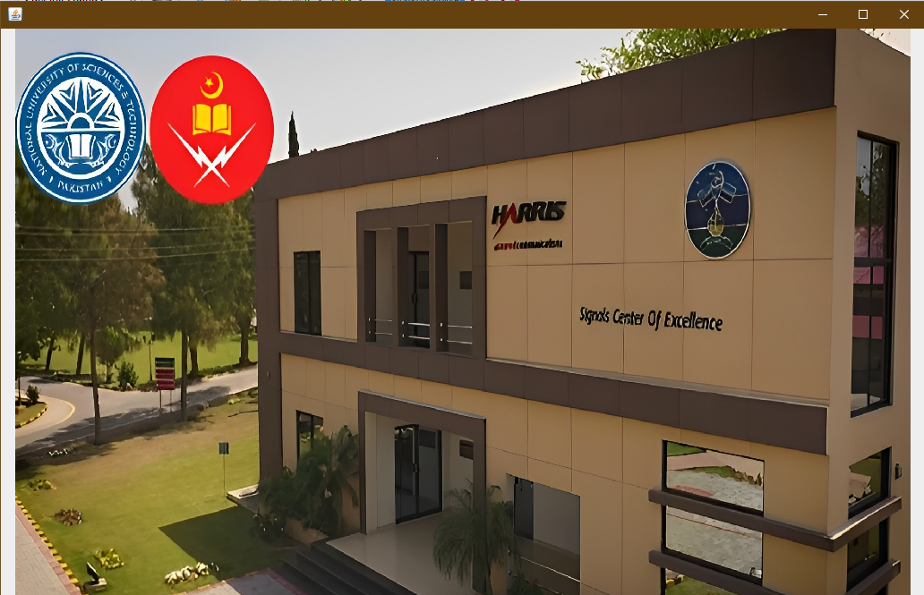

* **Program Code for LOGIN Window**

package college.management.system;

/**

*

* @author Muhammad Ahmad Sultan

*/

import javax.swing.*;

import java.awt.*;

import java.awt.event.*;

import java.sql.*;

public class Login extends JFrame implements ActionListener{

JButton login, cancel;

JTextField username, password;

Login () {

getContentPane().setBackground(Color.DARK_GRAY);

setLayout(null);

JLabel lblusername = new JLabel("Username");

lblusername.setBounds(40, 20, 100, 20);

lblusername.setForeground(Color.WHITE);

add(lblusername);

username = new JTextField();

username.setBounds(150, 20, 150, 20);

add(username);

JLabel lblpassword = new JLabel("Password");

lblpassword.setBounds(40, 70, 100, 20);

lblpassword.setForeground(Color.WHITE);

add(lblpassword);

password = new JPasswordField();

password.setBounds(150, 70, 150, 20);

add(password);

login = new JButton("Login");

login.setBounds(40, 140, 120, 30);

login.setBackground(Color.BLACK);

login.setForeground(Color.YELLOW);

login.addActionListener(this);

login.setFont(new Font("Tahoma", Font.BOLD, 15));

add(login);

cancel = new JButton("Cancel");

cancel.setBounds(180, 140, 120, 30);

cancel.setBackground(Color.BLACK);

cancel.setForeground(Color.RED);

cancel.addActionListener(this);

cancel.setFont(new Font("Tahoma", Font.BOLD, 15));

add(cancel);

ImageIcon i1 = new ImageIcon(ClassLoader.getSystemResource("icons/login.png"));

Image i2 = i1.getImage().getScaledInstance(200, 200, Image.SCALE_DEFAULT);

ImageIcon i3 = new ImageIcon(i2);

JLabel image = new JLabel(i3);

image.setBounds(350, 0, 200, 200);

add(image);

setSize(600, 300);

setLocation(500, 250);

setVisible(true);

}

public void actionPerformed(ActionEvent ae) {

if (ae.getSource() == login) {

String username_ = this.username.getText();

String password_ = this.password.getText();

String query = "select * from login where username='"+username_+"' and password='"+password_+"'";

try {

dbConnectivity c = new dbConnectivity();

ResultSet rs = c.s.executeQuery(query);

if (rs.next()) {

setVisible(false);

new Project();

} else {

JOptionPane.showMessageDialog(null, "Invalid username or password");

setVisible(false);

}

} catch (Exception e) {

e.printStackTrace();

}

} else if (ae.getSource() == cancel) {

setVisible(false);

}

}

public static void main(String[] args) {

new Login();

}

}

* **OUTPUT (ScreenShot) for LOGIN Window**
* **Program Code for DASHBOARD Window**

package college.management.system;

/**

*

* @author Muhammad Ahmad Sultan

*/

import javax.swing.*;

import java.awt.*;

import java.awt.event.*;

public class Project extends JFrame implements ActionListener {

Project() {

setSize(1300, 700);

ImageIcon i1 = new ImageIcon(ClassLoader.getSystemResource("icons/Nust.png"));

Image i2 = i1.getImage().getScaledInstance(1300, 700, Image.SCALE_DEFAULT);

ImageIcon i3 = new ImageIcon(i2);

JLabel image = new JLabel(i3);

add(image);

JMenuBar mb = new JMenuBar();

mb.setBackground(Color.LIGHT_GRAY);

// New Information

JMenu newInformation = new JMenu("New Info");

newInformation.setForeground(Color.BLUE);

newInformation.setFont(new Font("sansserif", Font.BOLD, 16));

mb.add(newInformation);

JMenuItem facultyInfo = new JMenuItem("New Faculty Information");

facultyInfo.setBackground(Color.WHITE);

facultyInfo.addActionListener(this);

facultyInfo.setFont(new Font("sansserif", Font.PLAIN, 16));

newInformation.add(facultyInfo);

JMenuItem studentInfo = new JMenuItem("New Student Information");

studentInfo.setBackground(Color.WHITE);

studentInfo.addActionListener(this);

studentInfo.setFont(new Font("sansserif", Font.PLAIN, 16));

newInformation.add(studentInfo);

// Details

JMenu details = new JMenu("View Details");

details.setForeground(Color.BLACK);

details.setFont(new Font("sansserif", Font.BOLD, 16));

mb.add(details);

JMenuItem facultydetails = new JMenuItem("View Faculty Details");

facultydetails.setBackground(Color.WHITE);

facultydetails.addActionListener(this);

facultydetails.setFont(new Font("sansserif", Font.PLAIN, 16));

details.add(facultydetails);

JMenuItem studentdetails = new JMenuItem("View Student Details");

studentdetails.setBackground(Color.WHITE);

studentdetails.addActionListener(this);

studentdetails.setFont(new Font("sansserif", Font.PLAIN, 16));

details.add(studentdetails);

// Leave

JMenu leave = new JMenu("Apply Leave");

leave.setForeground(Color.BLUE);

leave.setFont(new Font("sansserif", Font.BOLD, 16));

mb.add(leave);

JMenuItem facultyleave = new JMenuItem("Faculty Leave");

facultyleave.setBackground(Color.WHITE);

facultyleave.addActionListener(this);

facultyleave.setFont(new Font("sansserif", Font.PLAIN, 16));

leave.add(facultyleave);

JMenuItem studentleave = new JMenuItem("Student Leave");

studentleave.setBackground(Color.WHITE);

studentleave.addActionListener(this);

studentleave.setFont(new Font("sansserif", Font.PLAIN, 16));

leave.add(studentleave);

// Leave Details

JMenu leaveDetails = new JMenu("Leave Details");

leaveDetails.setForeground(Color.BLACK);

leaveDetails.setFont(new Font("sansserif", Font.BOLD, 16));

mb.add(leaveDetails);

JMenuItem facultyleavedetails = new JMenuItem("Faculty Leave Details");

facultyleavedetails.setBackground(Color.WHITE);

facultyleavedetails.addActionListener(this);

facultyleavedetails.setFont(new Font("sansserif", Font.PLAIN, 16));

leaveDetails.add(facultyleavedetails);

JMenuItem studentleavedetails = new JMenuItem("Student Leave Details");

studentleavedetails.setBackground(Color.WHITE);

studentleavedetails.addActionListener(this);

studentleavedetails.setFont(new Font("sansserif", Font.PLAIN, 16));

leaveDetails.add(studentleavedetails);

// Exams

JMenu exam = new JMenu("Exams Details");

exam.setForeground(Color.BLUE);

exam.setFont(new Font("sansserif", Font.BOLD, 16));

mb.add(exam);

JMenuItem examinationdetails = new JMenuItem("Examination Results");

examinationdetails.setBackground(Color.WHITE);

examinationdetails.addActionListener(this);

examinationdetails.setFont(new Font("sansserif", Font.PLAIN, 16));

exam.add(examinationdetails);

JMenuItem entermarks = new JMenuItem("Enter Marks");

entermarks.setBackground(Color.WHITE);

entermarks.addActionListener(this);

entermarks.setFont(new Font("sansserif", Font.PLAIN, 16));

exam.add(entermarks);

// UpdateInfo

JMenu updateInfo = new JMenu("Update Details");

updateInfo.setForeground(Color.BLACK);

updateInfo.setFont(new Font("sansserif", Font.BOLD, 16));

mb.add(updateInfo);

JMenuItem updatefacultyinfo = new JMenuItem("Update Faculty Details");

updatefacultyinfo.setBackground(Color.WHITE);

updatefacultyinfo.addActionListener(this);

updatefacultyinfo.setFont(new Font("sansserif", Font.PLAIN, 16));

updateInfo.add(updatefacultyinfo);

JMenuItem updatestudentinfo = new JMenuItem("Update Student Details");

updatestudentinfo.setBackground(Color.WHITE);

updatestudentinfo.addActionListener(this);

updatestudentinfo .setFont(new Font("sansserif", Font.PLAIN, 16));

updateInfo.add(updatestudentinfo);

// fee

JMenu fee = new JMenu("Fee Details");

fee.setForeground(Color.BLUE);

fee.setFont(new Font("sansserif", Font.BOLD, 16));

mb.add(fee);

JMenuItem feestructure = new JMenuItem("Fee Structure");

feestructure.setBackground(Color.WHITE);

feestructure.addActionListener(this);

feestructure .setFont(new Font("sansserif", Font.PLAIN, 16));

fee.add(feestructure);

JMenuItem feeform = new JMenuItem("Student Fee Form");

feeform.setBackground(Color.WHITE);

feeform.addActionListener(this);

feeform .setFont(new Font("sansserif", Font.PLAIN, 16));

fee.add(feeform);

// Utility

JMenu utility = new JMenu("Utility");

utility.setForeground(Color.BLACK);

utility.setFont(new Font("sansserif", Font.BOLD, 16));

mb.add(utility);

JMenuItem notepad = new JMenuItem("Notepad");

notepad.setBackground(Color.BLACK);

notepad.addActionListener(this);

notepad .setFont(new Font("sansserif", Font.PLAIN, 16));

utility.add(notepad);

JMenuItem calc = new JMenuItem("Calculator");

calc.setBackground(Color.WHITE);

calc.addActionListener(this);

calc.setFont(new Font("sansserif", Font.PLAIN, 16));

utility.add(calc);

// about

JMenu about = new JMenu("About");

about.setForeground(Color.MAGENTA);

about.setFont(new Font("sansserif", Font.BOLD|Font.ITALIC, 16));

mb.add(about);

JMenuItem ab = new JMenuItem("About");

ab.setBackground(Color.WHITE);

ab.addActionListener(this);

ab.setFont(new Font("sansserif", Font.PLAIN, 16));

about.add(ab);

// exit

JMenu exit = new JMenu("Exit");

exit.setForeground(Color.RED);

exit.setFont(new Font("sansserif", Font.BOLD, 16));

mb.add(exit);

JMenuItem ex = new JMenuItem("Exit");

ex.setBackground(Color.WHITE);

ex.addActionListener(this);

ex.setFont(new Font("sansserif", Font.PLAIN, 16));

exit.add(ex);

setJMenuBar(mb);

setVisible(true);

}

public void actionPerformed(ActionEvent ae) {

String msg = ae.getActionCommand();

if (msg.equals("Exit")) {

setVisible(false);

} else if (msg.equals("Calculator")) {

try {

Runtime.getRuntime().exec("calc.exe");

} catch (Exception e) {

}

} else if (msg.equals("Notepad")) {

try {

Runtime.getRuntime().exec("notepad.exe");

} catch (Exception e) {

}

} else if (msg.equals("New Faculty Information")) {

new AddTeacher();

} else if (msg.equals("New Student Information")) {

new AddStudent();

} else if (msg.equals("View Faculty Details")) {

new TeacherDetails();

} else if (msg.equals("View Student Details")) {

new StudentDetails();

} else if (msg.equals("Faculty Leave")) {

new TeacherLeave();

} else if (msg.equals("Student Leave")) {

new StudentLeave();

} else if (msg.equals("Faculty Leave Details")) {

new TeacherLeaveDetails();

} else if (msg.equals("Student Leave Details")) {

new StudentLeaveDetails();

} else if (msg.equals("Update Faculty Details")) {

new UpdateTeacher();

} else if (msg.equals("Update Student Details")) {

new UpdateStudent();

} else if (msg.equals("Enter Marks")) {

new EnterMarks();

} else if (msg.equals("Examination Results")) {

new ExaminationDetails();

} else if (msg.equals("Fee Structure")) {

new FeeStructure();

} else if (msg.equals("About")) {

new About();

} else if (msg.equals("Student Fee Form")) {

new StudentFeeForm();

}

}

public static void main(String[] args) {

new Project();

}

}

* **OUTPUT (ScreenShot) for DASHBOARD Window**

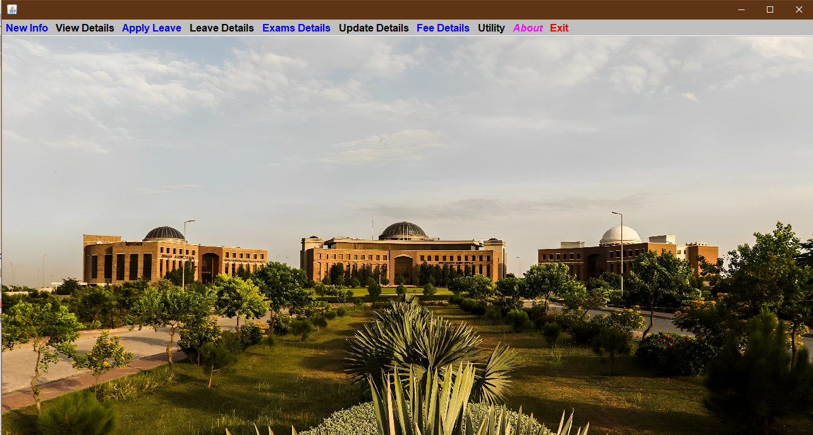

* **Program Code for ADD NEW STUDENT Window**

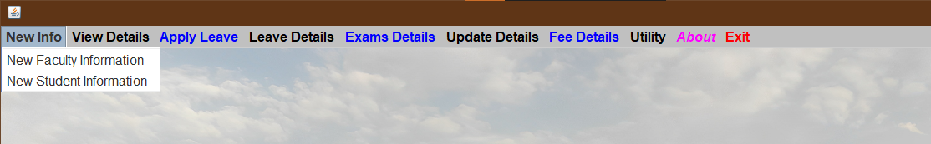

package college.management.system;

/**

*

* @author Muhammad Ahmad Sultan

*/

import javax.swing.*;

import java.awt.*;

import java.util.*;

import com.toedter.calendar.JDateChooser;

import java.awt.event.*;

public class AddStudent extends JFrame implements ActionListener{

JTextField tfname, tffname, tfaddress, tfphone, tfemail, tfx, tfxii, tfcnic;

JLabel labelrollno;

JDateChooser dcdob;

JComboBox cbcourse, cbbranch;

JButton submit, cancel;

Random ran = new Random();

long first4 = Math.abs((ran.nextLong() % 9000L) + 1000L);

AddStudent() {

setSize(900, 700);

setLocation(350, 50);

setLayout(null);

JLabel heading = new JLabel(" Student (New Comer) Info");

heading.setBounds(240, 30, 500, 50);

heading.setFont(new Font("serif", Font.BOLD, 30));

add(heading);

JLabel lblname = new JLabel("Name");

lblname.setBounds(50, 150, 100, 30);

lblname.setFont(new Font("serif", Font.BOLD, 20));

add(lblname);

tfname = new JTextField();

tfname.setBounds(200, 150, 150, 30);

add(tfname);

JLabel lblfname = new JLabel("Father's Name");

lblfname.setBounds(400, 150, 200, 30);

lblfname.setFont(new Font("serif", Font.BOLD, 20));

add(lblfname);

tffname = new JTextField();

tffname.setBounds(600, 150, 150, 30);

add(tffname);

JLabel lblrollno = new JLabel("Roll Number");

lblrollno.setBounds(50, 200, 200, 30);

lblrollno.setFont(new Font("serif", Font.BOLD, 20));

add(lblrollno);

labelrollno = new JLabel("1533"+first4);

labelrollno.setBounds(200, 200, 200, 30);

labelrollno.setFont(new Font("serif", Font.BOLD, 20));

add(labelrollno);

JLabel lbldob = new JLabel("Date of Birth");

lbldob.setBounds(400, 200, 200, 30);

lbldob.setFont(new Font("serif", Font.BOLD, 20));

add(lbldob);

dcdob = new JDateChooser();

dcdob.setBounds(600, 200, 150, 30);

add(dcdob);

JLabel lbladdress = new JLabel("Address");

lbladdress.setBounds(50, 250, 200, 30);

lbladdress.setFont(new Font("serif", Font.BOLD, 20));

add(lbladdress);

tfaddress = new JTextField();

tfaddress.setBounds(200, 250, 150, 30);

add(tfaddress);

JLabel lblphone = new JLabel("Phone");

lblphone.setBounds(400, 250, 200, 30);

lblphone.setFont(new Font("serif", Font.BOLD, 20));

add(lblphone);

tfphone = new JTextField();

tfphone.setBounds(600, 250, 150, 30);

add(tfphone);

JLabel lblemail = new JLabel("Email Id");

lblemail.setBounds(50, 300, 200, 30);

lblemail.setFont(new Font("serif", Font.BOLD, 20));

add(lblemail);

tfemail = new JTextField();

tfemail.setBounds(200, 300, 150, 30);

add(tfemail);

JLabel lblx = new JLabel("MATRIC '%'");

lblx.setBounds(400, 300, 200, 30);

lblx.setFont(new Font("serif", Font.BOLD, 20));

add(lblx);

tfx = new JTextField();

tfx.setBounds(600, 300, 150, 30);

add(tfx);

JLabel lblxii = new JLabel("FSc '%' ");

lblxii.setBounds(50, 350, 200, 30);

lblxii.setFont(new Font("serif", Font.BOLD, 20));

add(lblxii);

tfxii = new JTextField();

tfxii.setBounds(200, 350, 150, 30);

add(tfxii);

JLabel lblcnic = new JLabel("CNIC Number");

lblcnic.setBounds(400, 350, 200, 30);

lblcnic.setFont(new Font("serif", Font.BOLD, 20));

add(lblcnic);

tfcnic = new JTextField();

tfcnic.setBounds(600, 350, 150, 30);

add(tfcnic);

JLabel lblcourse = new JLabel("Course");

lblcourse.setBounds(50, 400, 200, 30);

lblcourse.setFont(new Font("serif", Font.BOLD, 20));

add(lblcourse);

String course[] = {"Bachelors", "Masters", "PhD"};

cbcourse = new JComboBox(course);

cbcourse.setBounds(200, 400, 150, 30);

cbcourse.setBackground(Color.WHITE);

add(cbcourse);

JLabel lblbranch = new JLabel("Branch");

lblbranch.setBounds(400, 400, 200, 30);

lblbranch.setFont(new Font("serif", Font.BOLD, 20));

add(lblbranch);

String branch[] = {"Software Engineering", "Computer Science", "Electrical Engineering", "Info Security", "Telecom"};

cbbranch = new JComboBox(branch);

cbbranch.setBounds(600, 400, 150, 30);

cbbranch.setBackground(Color.WHITE);

add(cbbranch);

submit = new JButton("Submit");

submit.setBounds(250, 550, 120, 30);

submit.setBackground(Color.BLACK);

submit.setForeground(Color.CYAN);

submit.addActionListener(this);

submit.setFont(new Font("Tahoma", Font.BOLD, 15));

add(submit);

cancel = new JButton("Cancel");

cancel.setBounds(450, 550, 120, 30);

cancel.setBackground(Color.BLACK);

cancel.setForeground(Color.RED);

cancel.addActionListener(this);

cancel.setFont(new Font("Tahoma", Font.BOLD, 15));

add(cancel);

setVisible(true);

}

public void actionPerformed(ActionEvent ae) {

if (ae.getSource() == submit) {

String name = tfname.getText();

String fname = tffname.getText();

String rollno = labelrollno.getText();

String dob = ((JTextField) dcdob.getDateEditor().getUiComponent()).getText();

String address = tfaddress.getText();

String phone = tfphone.getText();

String email = tfemail.getText();

String x = tfx.getText();

String xii = tfxii.getText();

String cnic = tfcnic.getText();

String course = (String) cbcourse.getSelectedItem();

String branch = (String) cbbranch.getSelectedItem();

try {

String query = "insert into student values('"+name+"', '"+fname+"', '"+rollno+"', '"+dob+"', '"+address+"', '"+phone+"', '"+email+"', '"+x+"', '"+xii+"', '"+cnic+"', '"+course+"', '"+branch+"')";

dbConnectivity con = new dbConnectivity();

con.s.executeUpdate(query);

JOptionPane.showMessageDialog(null, "Student Details Added Successfully");

setVisible(false);

} catch (Exception e) {

e.printStackTrace();

}

} else {

setVisible(false);

}

}

public static void main(String[] args) {

new AddStudent();

}

}

* **OUTPUT (ScreenShot) for ADD NEW STUDENT Window**

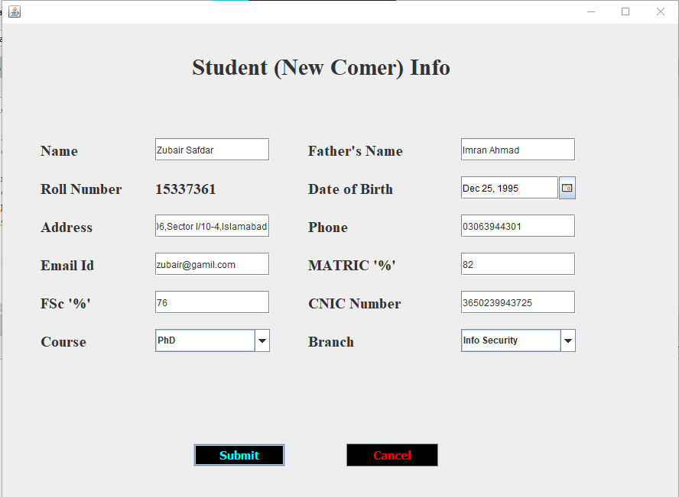

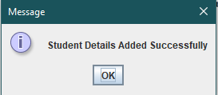

* **Program Code for ADD NEW TEACHER Window**



/*

* Click nbfs://nbhost/SystemFileSystem/Templates/Licenses/license-default.txt to change this license

* Click nbfs://nbhost/SystemFileSystem/Templates/Classes/Class.java to edit this template

*/

package college.management.system;

/**

*

* @author Muhammad Ahmad Sultan

*/

import javax.swing.*;

import java.awt.*;

import java.util.*;

import com.toedter.calendar.JDateChooser;

import java.awt.event.*;

public class AddTeacher extends JFrame implements ActionListener{

JTextField tfname, tffname, tfaddress, tfphone, tfemail, tfx, tfxii, tfcnic;

JLabel labelempId;

JDateChooser dcdob;

JComboBox cbcourse, cbbranch;

JButton submit, cancel;

Random ran = new Random();

long first4 = Math.abs((ran.nextLong() % 9000L) + 1000L);

AddTeacher() {

setSize(900, 700);

setLocation(350, 50);

setLayout(null);

JLabel heading = new JLabel("New Teacher (Faculty) Details");

heading.setBounds(260, 30, 500, 50);

heading.setFont(new Font("serif", Font.BOLD, 30));

add(heading);

JLabel lblname = new JLabel("Name");

lblname.setBounds(50, 150, 100, 30);

lblname.setFont(new Font("serif", Font.BOLD, 20));

add(lblname);

tfname = new JTextField();

tfname.setBounds(200, 150, 150, 30);

add(tfname);

JLabel lblfname = new JLabel("Father's Name");

lblfname.setBounds(400, 150, 200, 30);

lblfname.setFont(new Font("serif", Font.BOLD, 20));

add(lblfname);

tffname = new JTextField();

tffname.setBounds(600, 150, 150, 30);

add(tffname);

JLabel lblempId = new JLabel("Employee Id");

lblempId.setBounds(50, 200, 200, 30);

lblempId.setFont(new Font("serif", Font.BOLD, 20));

add(lblempId);

labelempId = new JLabel("101"+first4);

labelempId.setBounds(200, 200, 200, 30);

labelempId.setFont(new Font("serif", Font.BOLD, 20));

add(labelempId);

JLabel lbldob = new JLabel("Date of Birth");

lbldob.setBounds(400, 200, 200, 30);

lbldob.setFont(new Font("serif", Font.BOLD, 20));

add(lbldob);

dcdob = new JDateChooser();

dcdob.setBounds(600, 200, 150, 30);

add(dcdob);

JLabel lbladdress = new JLabel("Address");

lbladdress.setBounds(50, 250, 200, 30);

lbladdress.setFont(new Font("serif", Font.BOLD, 20));

add(lbladdress);

tfaddress = new JTextField();

tfaddress.setBounds(200, 250, 150, 30);

add(tfaddress);

JLabel lblphone = new JLabel("Phone");

lblphone.setBounds(400, 250, 200, 30);

lblphone.setFont(new Font("serif", Font.BOLD, 20));

add(lblphone);

tfphone = new JTextField();

tfphone.setBounds(600, 250, 150, 30);

add(tfphone);

JLabel lblemail = new JLabel("Email Id");

lblemail.setBounds(50, 300, 200, 30);

lblemail.setFont(new Font("serif", Font.BOLD, 20));

add(lblemail);

tfemail = new JTextField();

tfemail.setBounds(200, 300, 150, 30);

add(tfemail);

JLabel lblx = new JLabel("MATRIC '%'");

lblx.setBounds(400, 300, 200, 30);

lblx.setFont(new Font("serif", Font.BOLD, 20));

add(lblx);

tfx = new JTextField();

tfx.setBounds(600, 300, 150, 30);

add(tfx);

JLabel lblxii = new JLabel("FSc '%'");

lblxii.setBounds(50, 350, 200, 30);

lblxii.setFont(new Font("serif", Font.BOLD, 20));

add(lblxii);

tfxii = new JTextField();

tfxii.setBounds(200, 350, 150, 30);

add(tfxii);

JLabel lblaadhar = new JLabel("CNIC Number");

lblaadhar.setBounds(400, 350, 200, 30);

lblaadhar.setFont(new Font("serif", Font.BOLD, 20));

add(lblaadhar);

tfcnic = new JTextField();

tfcnic.setBounds(600, 350, 150, 30);

add(tfcnic);

JLabel lblcourse = new JLabel("Qualification");

lblcourse.setBounds(50, 400, 200, 30);

lblcourse.setFont(new Font("serif", Font.BOLD, 20));

add(lblcourse);

String course[] = { "PhD","MS","BS","B.Tech"};

cbcourse = new JComboBox(course);

cbcourse.setBounds(200, 400, 150, 30);

cbcourse.setBackground(Color.WHITE);

add(cbcourse);

JLabel lblbranch = new JLabel("Department");

lblbranch.setBounds(400, 400, 200, 30);

lblbranch.setFont(new Font("serif", Font.BOLD, 20));

add(lblbranch);

String branch[] = {"Software Engineering", "Computer Science", "Electrical Engineering", "Info Security", "Telecom"};

cbbranch = new JComboBox(branch);

cbbranch.setBounds(600, 400, 150, 30);

cbbranch.setBackground(Color.WHITE);

add(cbbranch);

submit = new JButton("Submit");

submit.setBounds(250, 550, 120, 30);

submit.setBackground(Color.BLACK);

submit.setForeground(Color.CYAN);

submit.addActionListener(this);

submit.setFont(new Font("Tahoma", Font.BOLD, 15));

add(submit);

cancel = new JButton("Cancel");

cancel.setBounds(450, 550, 120, 30);

cancel.setBackground(Color.BLACK);

cancel.setForeground(Color.RED);

cancel.addActionListener(this);

cancel.setFont(new Font("Tahoma", Font.BOLD, 15));

add(cancel);

setVisible(true);

}

public void actionPerformed(ActionEvent ae) {

if (ae.getSource() == submit) {

String name = tfname.getText();

String fname = tffname.getText();

String rollno = labelempId.getText();

String dob = ((JTextField) dcdob.getDateEditor().getUiComponent()).getText();

String address = tfaddress.getText();

String phone = tfphone.getText();

String email = tfemail.getText();

String x = tfx.getText();

String xii = tfxii.getText();

String cnic = tfcnic.getText();

String course = (String) cbcourse.getSelectedItem();

String branch = (String) cbbranch.getSelectedItem();

try {

String query = "insert into teacher values('"+name+"', '"+fname+"', '"+rollno+"', '"+dob+"', '"+address+"', '"+phone+"', '"+email+"', '"+x+"', '"+xii+"', '"+cnic+"', '"+course+"', '"+branch+"')";

dbConnectivity con = new dbConnectivity();

con.s.executeUpdate(query);

JOptionPane.showMessageDialog(null, "Teacher Details Added Successfully");

setVisible(false);

} catch (Exception e) {

e.printStackTrace();

}

} else {

setVisible(false);

}

}

public static void main(String[] args) {

new AddTeacher();

}

}

* **OUTPUT (ScreenShot) for ADD NEW TEACHER Window**

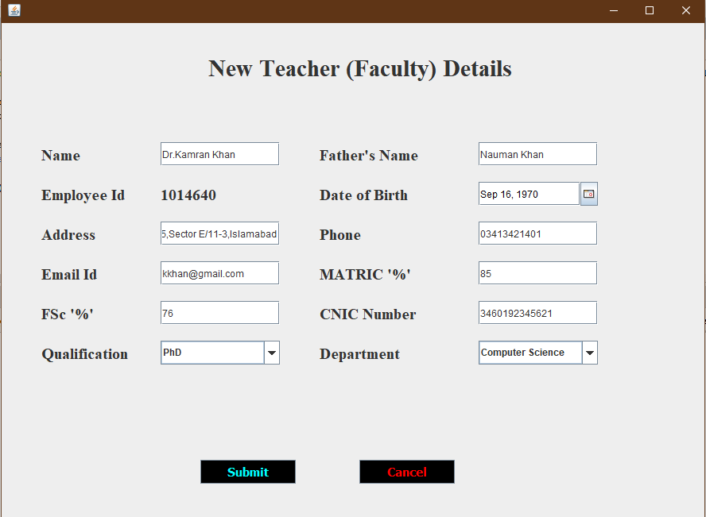

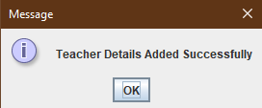

* **Program Code for STUDENT DETAILS Window**

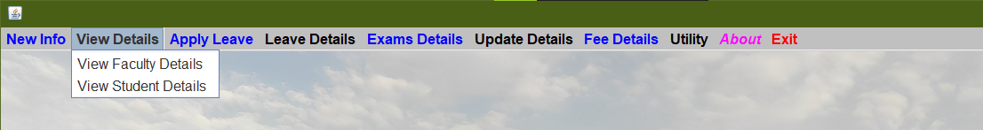

/*

* Click nbfs://nbhost/SystemFileSystem/Templates/Licenses/license-default.txt to change this license

* Click nbfs://nbhost/SystemFileSystem/Templates/Classes/Class.java to edit this template

*/

package college.management.system;

/**

*

* @author Muhammad Ahmad Sultan

*/

import javax.swing.*;

import java.awt.*;

import java.sql.*;

import net.proteanit.sql.DbUtils;

import java.awt.event.*;

public class StudentDetails extends JFrame implements ActionListener {

Choice crollno;

JTable table;

JButton search, print, update, add, cancel;

StudentDetails() {

getContentPane().setBackground(Color.WHITE);

setLayout(null);

JLabel heading = new JLabel("Search by Roll Number");

heading.setBounds(20, 20, 150, 20);

add(heading);

crollno = new Choice();

crollno.setBounds(180, 20, 150, 20);

add(crollno);

try {

dbConnectivity c = new dbConnectivity();

ResultSet rs = c.s.executeQuery("select * from student");

while(rs.next()) {

crollno.add(rs.getString("rollno"));

}

} catch (Exception e) {

e.printStackTrace();

}

table = new JTable();

try {

dbConnectivity c = new dbConnectivity();

ResultSet rs = c.s.executeQuery("select * from student");

table.setModel(DbUtils.resultSetToTableModel(rs));

} catch (Exception e) {

e.printStackTrace();

}

JScrollPane jsp = new JScrollPane(table);

jsp.setBounds(0, 100, 900, 600);

add(jsp);

search = new JButton("Search");

search.setBounds(20, 70, 80, 20);

search.addActionListener(this);

add(search);

print = new JButton("Print");

print.setBounds(120, 70, 80, 20);

print.addActionListener(this);

add(print);

add = new JButton("Add");

add.setBounds(220, 70, 80, 20);

add.addActionListener(this);

add(add);

update = new JButton("Update");

update.setBounds(320, 70, 80, 20);

update.addActionListener(this);

add(update);

cancel = new JButton("Cancel");

cancel.setBounds(420, 70, 80, 20);

cancel.addActionListener(this);

add(cancel);

setSize(900, 700);

setLocation(300, 100);

setVisible(true);

}

public void actionPerformed(ActionEvent ae) {

if (ae.getSource() == search) {

String query = "select * from student where rollno = '"+crollno.getSelectedItem()+"'";

try {

dbConnectivity c = new dbConnectivity();

ResultSet rs = c.s.executeQuery(query);

table.setModel(DbUtils.resultSetToTableModel(rs));

} catch (Exception e) {

e.printStackTrace();

}

} else if (ae.getSource() == print) {

try {

table.print();

} catch (Exception e) {

e.printStackTrace();

}

} else if (ae.getSource() == add) {

setVisible(false);

new AddStudent();

} else if (ae.getSource() == update) {

setVisible(false);

new UpdateStudent();

} else {

setVisible(false);

}

}

public static void main(String[] args) {

new StudentDetails();

}

}

* **OUTPUT (ScreenShot) for STUDENT DETAILS Window**

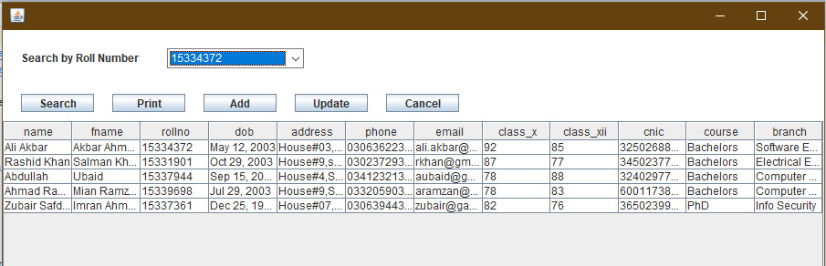

* **Program Code for TEACHER DETAILS Window**



/*

* Click nbfs://nbhost/SystemFileSystem/Templates/Licenses/license-default.txt to change this license

* Click nbfs://nbhost/SystemFileSystem/Templates/Classes/Class.java to edit this template

*/

package college.management.system;

/**

* @author Muhammad Ahmad Sultan

*/

import javax.swing.*;

import java.awt.*;

import java.sql.*;

import net.proteanit.sql.DbUtils;

import java.awt.event.*;

public class TeacherDetails extends JFrame implements ActionListener {

Choice cEmpId;

JTable table;

JButton search, print, update, add, cancel;

TeacherDetails() {

getContentPane().setBackground(Color.WHITE);

setLayout(null);

JLabel heading = new JLabel("Search by Employee Id");

heading.setBounds(20, 20, 150, 20);

add(heading);

cEmpId = new Choice();

cEmpId.setBounds(180, 20, 150, 20);

add(cEmpId);

try {

dbConnectivity c = new dbConnectivity();

ResultSet rs = c.s.executeQuery("select * from teacher");

while(rs.next()) {

cEmpId.add(rs.getString("empId"));

}

} catch (Exception e) {

e.printStackTrace();

}

table = new JTable();

try {

dbConnectivity c = new dbConnectivity();

ResultSet rs = c.s.executeQuery("select * from teacher");

table.setModel(DbUtils.resultSetToTableModel(rs));

} catch (Exception e) {

e.printStackTrace();

}

JScrollPane jsp = new JScrollPane(table);

jsp.setBounds(0, 100, 900, 600);

add(jsp);

search = new JButton("Search");

search.setBounds(20, 70, 80, 20);

search.addActionListener(this);

add(search);

print = new JButton("Print");

print.setBounds(120, 70, 80, 20);

print.addActionListener(this);

add(print);

add = new JButton("Add");

add.setBounds(220, 70, 80, 20);

add.addActionListener(this);

add(add);

update = new JButton("Update");

update.setBounds(320, 70, 80, 20);

update.addActionListener(this);

add(update);

cancel = new JButton("Cancel");

cancel.setBounds(420, 70, 80, 20);

cancel.addActionListener(this);

add(cancel);

setSize(900, 700);

setLocation(300, 100);

setVisible(true);

}

public void actionPerformed(ActionEvent ae) {

if (ae.getSource() == search) {

String query = "select * from teacher where rollno = '"+cEmpId.getSelectedItem()+"'";

try {

dbConnectivity c = new dbConnectivity();

ResultSet rs = c.s.executeQuery(query);

table.setModel(DbUtils.resultSetToTableModel(rs));

} catch (Exception e) {

e.printStackTrace();

}

} else if (ae.getSource() == print) {

try {

table.print();

} catch (Exception e) {

e.printStackTrace();

}

} else if (ae.getSource() == add) {

setVisible(false);

new AddTeacher();

} else if (ae.getSource() == update) {

setVisible(false);

new UpdateTeacher();

} else {

setVisible(false);

}

}

public static void main(String[] args) {

new TeacherDetails();

}

}

* **OUTPUT (ScreenShot) for TEACHER DETAILS Window**

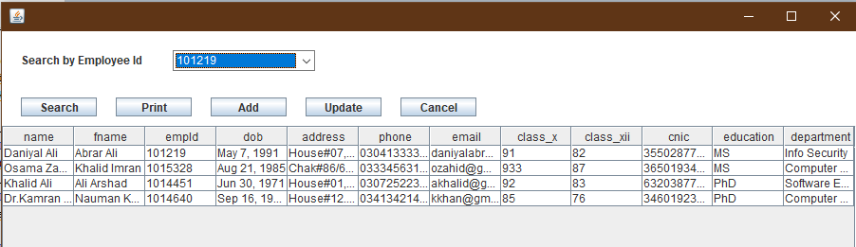

* **Program Code for STUDENT LEAVE Window**

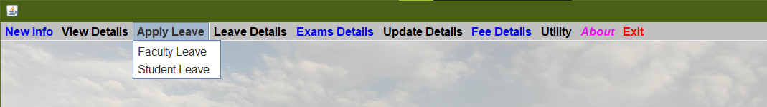

package college.management.system;

/**

*

* @author Muhammad Ahmad Sultan

*/

import javax.swing.*;

import java.awt.*;

import java.sql.*;

import com.toedter.calendar.JDateChooser;

import java.awt.event.*;

public class StudentLeave extends JFrame implements ActionListener {

Choice rollno_, time_;

JDateChooser dcdate;

JButton submit, cancel;

StudentLeave() {

setSize(500, 550);

setLocation(550, 100);

setLayout(null);

getContentPane().setBackground(Color.WHITE);

JLabel heading = new JLabel("Apply Leave (Student)");

heading.setBounds(40, 50, 300, 30);

heading.setFont(new Font("Tahoma", Font.BOLD, 20));

add(heading);

JLabel lblrollno = new JLabel("Search by Roll Number");

lblrollno.setBounds(60, 100, 200, 20);

lblrollno.setFont(new Font("Tahoma", Font.PLAIN, 18));

add(lblrollno);

rollno_ = new Choice();

rollno_.setBounds(60, 130, 200, 20);

add(rollno_);

try {

dbConnectivity c = new dbConnectivity();

ResultSet rs = c.s.executeQuery("select * from student");

while(rs.next()) {

rollno_.add(rs.getString("rollno"));

}

} catch (Exception e) {

e.printStackTrace();

}

JLabel lbldate = new JLabel("Date");

lbldate.setBounds(60, 180, 200, 20);

lbldate.setFont(new Font("Tahoma", Font.PLAIN, 18));

add(lbldate);

dcdate = new JDateChooser();

dcdate.setBounds(60, 210, 200, 25);

add(dcdate);

JLabel lbltime = new JLabel("Time Duration");

lbltime.setBounds(60, 260, 200, 20);

lbltime.setFont(new Font("Tahoma", Font.PLAIN, 18));

add(lbltime);

time_ = new Choice();

time_.setBounds(60, 290, 200, 20);

time_.add("Full Day");

time_.add("Half Day");

add(time_);

submit = new JButton("Submit");

submit.setBounds(60, 350, 100, 25);

submit.setBackground(Color.BLACK);

submit.setForeground(Color.CYAN);

submit.addActionListener(this);

submit.setFont(new Font("Tahoma", Font.BOLD, 15));

add(submit);

cancel = new JButton("Cancel");

cancel.setBounds(200, 350, 100, 25);

cancel.setBackground(Color.BLACK);

cancel.setForeground(Color.RED);

cancel.addActionListener(this);

cancel.setFont(new Font("Tahoma", Font.BOLD, 15));

add(cancel);

setVisible(true);

}

public void actionPerformed(ActionEvent ae) {

if (ae.getSource() == submit) {

String rollno = rollno_.getSelectedItem();

String date = ((JTextField) dcdate.getDateEditor().getUiComponent()).getText();

String duration = time_.getSelectedItem();

String query = "insert into studentleave values('"+rollno+"', '"+date+"', '"+duration+"')";

try {

dbConnectivity c = new dbConnectivity();

c.s.executeUpdate(query);

JOptionPane.showMessageDialog(null, "Leave Confirmed");

setVisible(false);

} catch (Exception e) {

e.printStackTrace();

}

} else {

setVisible(false);

}

}

public static void main(String[] args) {

new StudentLeave();

}

}

* **OUTPUT (ScreenShot) for STUDENT LEAVE Window**

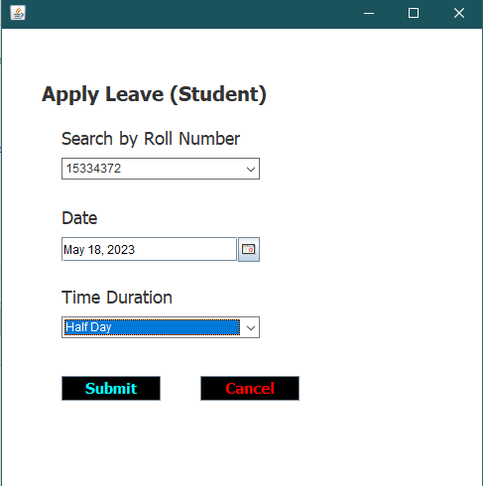

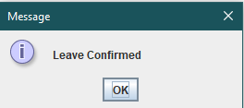

* **Program Code for TEACHER LEAVE Window**



/*

* Click nbfs://nbhost/SystemFileSystem/Templates/Licenses/license-default.txt to change this license

* Click nbfs://nbhost/SystemFileSystem/Templates/Classes/Class.java to edit this template

*/

package college.management.system;

/**

*

* @author Muhammad Ahmad Sultan

*/

import javax.swing.*;

import java.awt.*;

import java.sql.*;

import com.toedter.calendar.JDateChooser;

import java.awt.event.*;

public class TeacherLeave extends JFrame implements ActionListener {

Choice EmpId_, time_;

JDateChooser dcdate;

JButton submit, cancel;

TeacherLeave() {

setSize(500, 550);

setLocation(550, 100);

setLayout(null);

getContentPane().setBackground(Color.WHITE);

JLabel heading = new JLabel("Apply Leave (Teacher)");

heading.setBounds(40, 50, 300, 30);

heading.setFont(new Font("Tahoma", Font.BOLD, 20));

add(heading);

JLabel lblrollno = new JLabel("Search by Employee Id");

lblrollno.setBounds(60, 100, 200, 20);

lblrollno.setFont(new Font("Tahoma", Font.PLAIN, 18));

add(lblrollno);

EmpId_ = new Choice();

EmpId_.setBounds(60, 130, 200, 20);

add(EmpId_);

try {

dbConnectivity c = new dbConnectivity();

ResultSet rs = c.s.executeQuery("select * from teacher");

while(rs.next()) {

EmpId_.add(rs.getString("empId"));

}

} catch (Exception e) {

e.printStackTrace();

}

JLabel lbldate = new JLabel("Date");

lbldate.setBounds(60, 180, 200, 20);

lbldate.setFont(new Font("Tahoma", Font.PLAIN, 18));

add(lbldate);

dcdate = new JDateChooser();

dcdate.setBounds(60, 210, 200, 25);

add(dcdate);

JLabel lbltime = new JLabel("Time Duration");

lbltime.setBounds(60, 260, 200, 20);

lbltime.setFont(new Font("Tahoma", Font.PLAIN, 18));

add(lbltime);

time_ = new Choice();

time_.setBounds(60, 290, 200, 20);

time_.add("Full Day");

time_.add("Half Day");

add(time_);

submit = new JButton("Submit");

submit.setBounds(60, 350, 100, 25);

submit.setBackground(Color.BLACK);

submit.setForeground(Color.CYAN);

submit.addActionListener(this);

submit.setFont(new Font("Tahoma", Font.BOLD, 15));

add(submit);

cancel = new JButton("Cancel");

cancel.setBounds(200, 350, 100, 25);

cancel.setBackground(Color.BLACK);

cancel.setForeground(Color.RED);

cancel.addActionListener(this);

cancel.setFont(new Font("Tahoma", Font.BOLD, 15));

add(cancel);

setVisible(true);

}

public void actionPerformed(ActionEvent ae) {

if (ae.getSource() == submit) {

String rollno = EmpId_.getSelectedItem();

String date = ((JTextField) dcdate.getDateEditor().getUiComponent()).getText();

String duration = time_.getSelectedItem();

String query = "insert into teacherleave values('"+rollno+"', '"+date+"', '"+duration+"')";

try {

dbConnectivity c = new dbConnectivity();

c.s.executeUpdate(query);

JOptionPane.showMessageDialog(null, "Leave Confirmed");

setVisible(false);

} catch (Exception e) {

e.printStackTrace();

}

} else {

setVisible(false);

}

}

public static void main(String[] args) {

new TeacherLeave();

}

}

* **OUTPUT (ScreenShot) for TEACHER LEAVE Window**

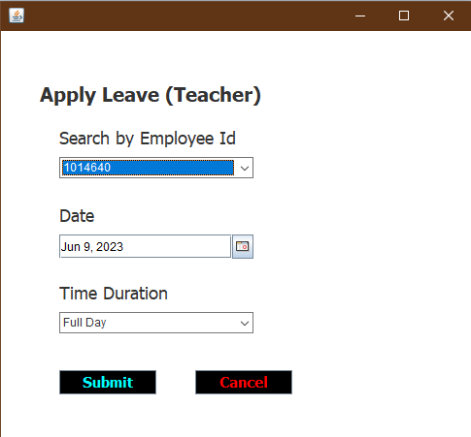



* **Program Code for STUDENT LEAVE DETAILS Window**

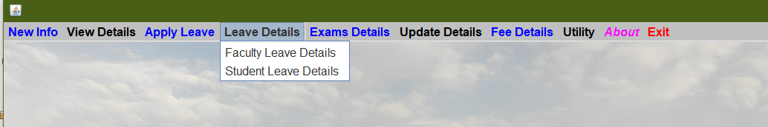

package college.management.system;

/**

*

* @author Muhammad Ahmad Sultan

*/

import javax.swing.*;

import java.awt.*;

import java.sql.*;

import net.proteanit.sql.DbUtils;

import java.awt.event.*;

public class StudentLeaveDetails extends JFrame implements ActionListener {

Choice rollno_;

JTable table;

JButton search, print, update, add, cancel;

StudentLeaveDetails() {

getContentPane().setBackground(Color.WHITE);

setLayout(null);

JLabel heading = new JLabel("Search by Roll Number");

heading.setBounds(20, 20, 150, 20);

add(heading);

rollno_ = new Choice();

rollno_.setBounds(180, 20, 150, 20);

add(rollno_);

try {

dbConnectivity c = new dbConnectivity();

ResultSet rs = c.s.executeQuery("select * from student");

while(rs.next()) {

rollno_.add(rs.getString("rollno"));

}

} catch (Exception e) {

e.printStackTrace();

}

table = new JTable();

try {

dbConnectivity c = new dbConnectivity();

ResultSet rs = c.s.executeQuery("select * from studentleave");

table.setModel(DbUtils.resultSetToTableModel(rs));

} catch (Exception e) {

e.printStackTrace();

}

JScrollPane jsp = new JScrollPane(table);

jsp.setBounds(0, 100, 900, 600);

add(jsp);

search = new JButton("Search");

search.setBounds(20, 70, 80, 20);

search.addActionListener(this);

add(search);

print = new JButton("Print");

print.setBounds(120, 70, 80, 20);

print.addActionListener(this);

add(print);

cancel = new JButton("Cancel");

cancel.setBounds(220, 70, 80, 20);

cancel.addActionListener(this);

add(cancel);

setSize(900, 700);

setLocation(300, 100);

setVisible(true);

}

public void actionPerformed(ActionEvent ae) {

if (ae.getSource() == search) {

String query = "select * from studentleave where rollno = '"+rollno_.getSelectedItem()+"'";

try {

dbConnectivity c = new dbConnectivity();

ResultSet rs = c.s.executeQuery(query);

table.setModel(DbUtils.resultSetToTableModel(rs));

} catch (Exception e) {

e.printStackTrace();

}

} else if (ae.getSource() == print) {

try {

table.print();

} catch (Exception e) {

e.printStackTrace();

}

} else {

setVisible(false);

}

}

public static void main(String[] args) {

new StudentLeaveDetails();

}

}

* **OUTPUT (ScreenShot) for STUDENT LEAVE DETAILS Window**

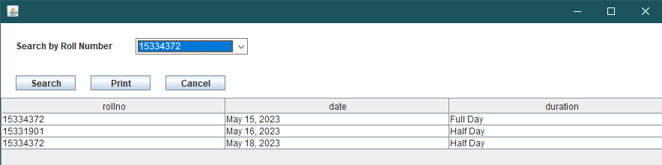

* **Program Code for TEACHER LEAVE DETAILS Window**



/*

* Click nbfs://nbhost/SystemFileSystem/Templates/Licenses/license-default.txt to change this license

* Click nbfs://nbhost/SystemFileSystem/Templates/Classes/Class.java to edit this template

*/

package college.management.system;

/**

*

* @author Muhammad Ahmad Sultan

*/

import javax.swing.*;

import java.awt.*;

import java.sql.*;

import net.proteanit.sql.DbUtils;

import java.awt.event.*;

public class TeacherLeaveDetails extends JFrame implements ActionListener {

Choice EmpId_;

JTable table;

JButton search, print, cancel;

TeacherLeaveDetails() {

getContentPane().setBackground(Color.WHITE);

setLayout(null);

JLabel heading = new JLabel("Search by Employee Id");

heading.setBounds(20, 20, 150, 20);

add(heading);

EmpId_ = new Choice();

EmpId_.setBounds(180, 20, 150, 20);

add(EmpId_);

try {

dbConnectivity c = new dbConnectivity();

ResultSet rs = c.s.executeQuery("select * from teacher");

while(rs.next()) {

EmpId_.add(rs.getString("empId"));

}

} catch (Exception e) {

e.printStackTrace();

}

table = new JTable();

try {

dbConnectivity c = new dbConnectivity();

ResultSet rs = c.s.executeQuery("select * from teacherleave");

table.setModel(DbUtils.resultSetToTableModel(rs));

} catch (Exception e) {

e.printStackTrace();

}

JScrollPane jsp = new JScrollPane(table);

jsp.setBounds(0, 100, 900, 600);

add(jsp);

search = new JButton("Search");

search.setBounds(20, 70, 80, 20);

search.addActionListener(this);

add(search);

print = new JButton("Print");

print.setBounds(120, 70, 80, 20);

print.addActionListener(this);

add(print);

cancel = new JButton("Cancel");

cancel.setBounds(220, 70, 80, 20);

cancel.addActionListener(this);

add(cancel);

setSize(900, 700);

setLocation(300, 100);

setVisible(true);

}

public void actionPerformed(ActionEvent ae) {

if (ae.getSource() == search) {

String query = "select * from teacherleave where rollno = '"+EmpId_.getSelectedItem()+"'";

try {

dbConnectivity c = new dbConnectivity();

ResultSet rs = c.s.executeQuery(query);

table.setModel(DbUtils.resultSetToTableModel(rs));

} catch (Exception e) {

e.printStackTrace();

}

} else if (ae.getSource() == print) {

try {

table.print();

} catch (Exception e) {

e.printStackTrace();

}

} else {

setVisible(false);

}

}

public static void main(String[] args) {

new TeacherLeaveDetails();

}

}

* **OUTPUT (ScreenShot) for TEACHER LEAVE DETAILS Window**

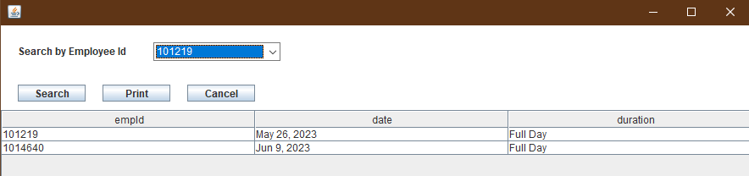

* **Program Code for EXAMS RESULT Window**

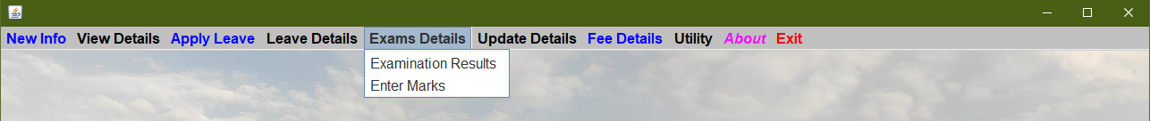

/*

* Click nbfs://nbhost/SystemFileSystem/Templates/Licenses/license-default.txt to change this license

* Click nbfs://nbhost/SystemFileSystem/Templates/Classes/Class.java to edit this template

*/

package college.management.system;

/**

*

* @author Muhammad Ahmad Sultan

*/

import java.awt.*;

import javax.swing.*;

import java.sql.*;

import java.awt.event.*;

public class Marks extends JFrame implements ActionListener {

String roll_no;

JButton cancel;

Marks(String rollno) {

this.roll_no = rollno;

setSize(500, 600);

setLocation(500, 100);

setLayout(null);

getContentPane().setBackground(Color.WHITE);

JLabel heading = new JLabel("Miltary College of Signals");

heading.setBounds(90, 10, 500, 25);

heading.setFont(new Font("Tahoma", Font.BOLD, 23));

heading.setForeground(Color.RED);

add(heading);

JLabel subheading = new JLabel(" Examination Results 2023");

subheading.setBounds(120, 50, 500, 20);

subheading.setFont(new Font("Tahoma", Font.BOLD, 18));

add(subheading);

JLabel lblrollno = new JLabel("Roll Number " + rollno);

lblrollno.setBounds(60, 100, 500, 20);

lblrollno.setFont(new Font("Tahoma", Font.PLAIN, 18));

add(lblrollno);

JLabel lblsemester = new JLabel();

lblsemester.setBounds(60, 130, 500, 20);

lblsemester.setFont(new Font("Tahoma", Font.PLAIN, 18));

add(lblsemester);

JLabel sub1 = new JLabel();

sub1.setBounds(100, 200, 500, 20);

sub1.setFont(new Font("Tahoma", Font.PLAIN, 18));

add(sub1);

JLabel sub2 = new JLabel();

sub2.setBounds(100, 230, 500, 20);

sub2.setFont(new Font("Tahoma", Font.PLAIN, 18));

add(sub2);

JLabel sub3 = new JLabel();

sub3.setBounds(100, 260, 500, 20);

sub3.setFont(new Font("Tahoma", Font.PLAIN, 18));

add(sub3);

JLabel sub4 = new JLabel();

sub4.setBounds(100, 290, 500, 20);

sub4.setFont(new Font("Tahoma", Font.PLAIN, 18));

add(sub4);

JLabel sub5 = new JLabel();

sub5.setBounds(100, 320, 500, 20);

sub5.setFont(new Font("Tahoma", Font.PLAIN, 18));

add(sub5);

try {

dbConnectivity c = new dbConnectivity();

ResultSet rs1 = c.s.executeQuery("select * from subject where rollno = '"+rollno+"'");

while(rs1.next()) {

sub1.setText(rs1.getString("subject1"));

sub2.setText(rs1.getString("subject2"));

sub3.setText(rs1.getString("subject3"));

sub4.setText(rs1.getString("subject4"));

sub5.setText(rs1.getString("subject5"));

}

ResultSet rs2 = c.s.executeQuery("select * from marks where rollno = '"+rollno+"'");

while(rs2.next()) {

sub1.setText(sub1.getText() + "------------" + rs2.getString("marks1"));

sub2.setText(sub2.getText() + "------------" + rs2.getString("marks2"));

sub3.setText(sub3.getText() + "------------" + rs2.getString("marks3"));

sub4.setText(sub4.getText() + "------------" + rs2.getString("marks4"));

sub5.setText(sub5.getText() + "------------" + rs2.getString("marks5"));

lblsemester.setText("Semester " + rs2.getString("semester"));

}

} catch (Exception e) {

e.printStackTrace();

}

cancel = new JButton("Back");

cancel.setBounds(200, 500, 120, 25);

cancel.setBackground(Color.BLACK);

cancel.setForeground(Color.YELLOW);

cancel.addActionListener(this);

cancel.setFont(new Font("Tahoma", Font.BOLD, 15));

add(cancel);

setVisible(true);

}

public void actionPerformed(ActionEvent ae) {

setVisible(false);

}

public static void main(String[] args) {

new Marks("");

}

}

* **OUTPUT (ScreenShot) for EXAMINATION DETAILS Window**

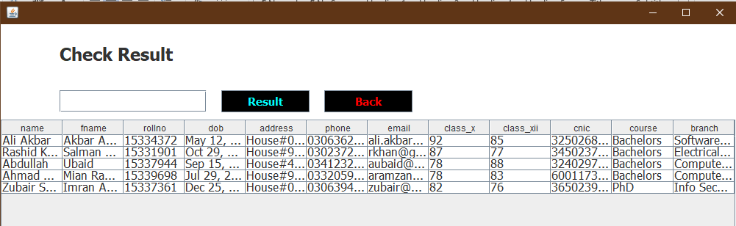

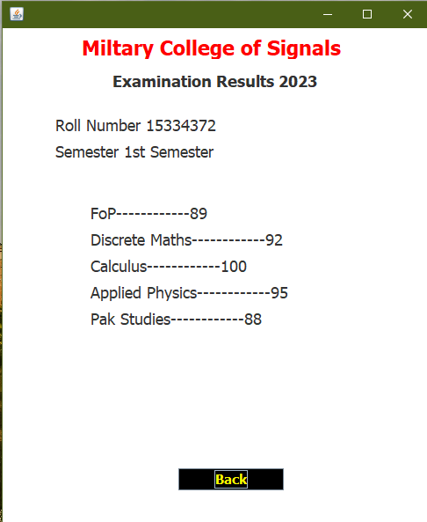

* **Program Code for ENTER MARKS Window**



/*

* Click nbfs://nbhost/SystemFileSystem/Templates/Licenses/license-default.txt to change this license

* Click nbfs://nbhost/SystemFileSystem/Templates/Classes/Class.java to edit this template

*/

package college.management.system;

/**

*

* @author Muhammad Ahmad Sultan

*/

import javax.swing.*;

import java.awt.*;

import java.sql.*;

import java.awt.event.*;

public class EnterMarks extends JFrame implements ActionListener {

Choice rollno_;

JComboBox cbsemester;

JTextField sub1_, sub2_,sub3_,sub4_,sub5_,marks1_,marks2_,marks3_,marks4_,marks5_;

JButton cancel, submit;

EnterMarks() {

setSize(1000, 500);

setLocation(300, 150);

setLayout(null);

getContentPane().setBackground(Color.WHITE);

ImageIcon i1 = new ImageIcon(ClassLoader.getSystemResource("icons/exam.png"));

Image i2 = i1.getImage().getScaledInstance(450, 450, Image.SCALE_DEFAULT);

ImageIcon i3 = new ImageIcon(i2);

JLabel image = new JLabel(i3);

image.setBounds(500, 40, 400, 300);

add(image);

JLabel heading = new JLabel("Enter Marks of Student");

heading.setBounds(50, 0, 500, 50);

heading.setFont(new Font("Tahoma", Font.BOLD, 20));

add(heading);

JLabel lblrollnumber = new JLabel("Select Roll Number");

lblrollnumber.setBounds(50, 70, 150, 20);

add(lblrollnumber);

rollno_ = new Choice();

rollno_.setBounds(200, 70, 150, 20);

add(rollno_);

try {

dbConnectivity c = new dbConnectivity();

ResultSet rs = c.s.executeQuery("select * from student");

while(rs.next()) {

rollno_.add(rs.getString("rollno"));

}

} catch (Exception e) {

e.printStackTrace();

}

JLabel lblsemester = new JLabel("Select Semester");

lblsemester.setBounds(50, 110, 150, 20);

add(lblsemester);

String semester[] = {"1st Semester", "2nd Semester", "3rd Semester", "4th Semester", "5th Semester", "6th Semester", "7th Semester", "8th Semester" };

cbsemester = new JComboBox(semester);

cbsemester.setBounds(200, 110, 150, 20);

cbsemester.setBackground(Color.WHITE);

add(cbsemester);

JLabel lblentersubject = new JLabel("Enter Subject");

lblentersubject.setBounds(100, 150, 200, 40);

add(lblentersubject);

JLabel lblentermarks = new JLabel("Enter Marks");

lblentermarks.setBounds(320, 150, 200, 40);

add(lblentermarks);

sub1_ = new JTextField();

sub1_.setBounds(50, 200, 200, 20);

add(sub1_);

sub2_ = new JTextField();

sub2_.setBounds(50, 230, 200, 20);

add(sub2_);

sub3_ = new JTextField();

sub3_.setBounds(50, 260, 200, 20);

add(sub3_);

sub4_ = new JTextField();

sub4_.setBounds(50, 290, 200, 20);

add(sub4_);

sub5_ = new JTextField();

sub5_.setBounds(50, 320, 200, 20);

add(sub5_);

marks1_ = new JTextField();

marks1_.setBounds(250, 200, 200, 20);

add(marks1_);

marks2_ = new JTextField();

marks2_.setBounds(250, 230, 200, 20);

add(marks2_);

marks3_ = new JTextField();

marks3_.setBounds(250, 260, 200, 20);

add(marks3_);

marks4_ = new JTextField();

marks4_.setBounds(250, 290, 200, 20);

add(marks4_);

marks5_ = new JTextField();

marks5_.setBounds(250, 320, 200, 20);

add(marks5_);

submit = new JButton("Submit");

submit.setBounds(70, 360, 150, 25);

submit.setBackground(Color.BLACK);

submit.setForeground(Color.WHITE);

submit.addActionListener(this);

submit.setFont(new Font("Tahoma", Font.BOLD, 15));

add(submit);

cancel = new JButton("Back");

cancel.setBounds(280, 360, 150, 25);

cancel.setBackground(Color.BLACK);

cancel.setForeground(Color.WHITE);

cancel.addActionListener(this);

cancel.setFont(new Font("Tahoma", Font.BOLD, 15));

add(cancel);

setVisible(true);

}

public void actionPerformed(ActionEvent ae) {

if (ae.getSource() == submit) {

try {

dbConnectivity c = new dbConnectivity();

String query1 = "insert into subject values('"+rollno_.getSelectedItem()+"', '"+cbsemester.getSelectedItem()+"', '"+sub1_.getText()+"', '"+sub2_.getText()+"', '"+sub3_.getText()+"', '"+sub4_.getText()+"', '"+sub5_.getText()+"')";

String query2 = "insert into marks values('"+rollno_.getSelectedItem()+"', '"+cbsemester.getSelectedItem()+"', '"+marks1_.getText()+"', '"+marks2_.getText()+"', '"+marks3_.getText()+"', '"+marks4_.getText()+"', '"+marks5_.getText()+"')";

c.s.executeUpdate(query1);

c.s.executeUpdate(query2);

JOptionPane.showMessageDialog(null, "Marks Added Sucessfully");

setVisible(false);

} catch (Exception e) {

e.printStackTrace();

}

} else {

setVisible(false);

}

}

public static void main(String[] args) {

new EnterMarks();

}

}

* **OUTPUT (ScreenShot) for ENTER MARKS Window**



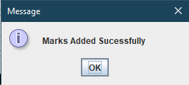

* **Program Code for UPDATE STUDENT DETAILS Window**

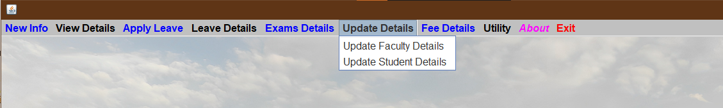

package college.management.system;

/**

*

* @author Muhammad Ahmad Sultan

*/

import javax.swing.*;

import java.awt.*;

import java.awt.event.*;

import java.sql.*;

public class UpdateStudent extends JFrame implements ActionListener{

JTextField tfcourse, tfaddress, tfphone, tfemail, tfbranch;

JLabel labelrollno;

JButton submit, cancel;

Choice crollno;

UpdateStudent() {

setSize(900, 650);

setLocation(350, 50);

setLayout(null);

JLabel heading = new JLabel("Update Student Details");

heading.setBounds(50, 10, 500, 50);

heading.setFont(new Font("Tahoma", Font.ITALIC, 35));

add(heading);

JLabel lblrollnumber = new JLabel("Select Roll Number");

lblrollnumber.setBounds(50, 100, 200, 20);

lblrollnumber.setFont(new Font("serif", Font.PLAIN, 20));

add(lblrollnumber);

crollno = new Choice();

crollno.setBounds(250, 100, 200, 20);

add(crollno);

try {

dbConnectivity c = new dbConnectivity();

ResultSet rs = c.s.executeQuery("select * from student");

while(rs.next()) {

crollno.add(rs.getString("rollno"));

}

} catch (Exception e) {

e.printStackTrace();

}

JLabel lblname = new JLabel("Name");

lblname.setBounds(50, 150, 100, 30);

lblname.setFont(new Font("serif", Font.BOLD, 20));

add(lblname);

JLabel labelname = new JLabel();

labelname.setBounds(200, 150, 150, 30);

labelname.setFont(new Font("Tahoma", Font.PLAIN, 18));

add(labelname);

JLabel lblfname = new JLabel("Father's Name");

lblfname.setBounds(400, 150, 200, 30);

lblfname.setFont(new Font("serif", Font.BOLD, 20));

add(lblfname);

JLabel labelfname = new JLabel();

labelfname.setBounds(600, 150, 150, 30);

labelfname.setFont(new Font("Tahoma", Font.PLAIN, 18));

add(labelfname);

JLabel lblrollno = new JLabel("Roll Number");

lblrollno.setBounds(50, 200, 200, 30);

lblrollno.setFont(new Font("serif", Font.BOLD, 20));

add(lblrollno);

labelrollno = new JLabel();

labelrollno.setBounds(200, 200, 200, 30);

labelrollno.setFont(new Font("Tahoma", Font.PLAIN, 18));

add(labelrollno);

JLabel lbldob = new JLabel("Date of Birth");

lbldob.setBounds(400, 200, 200, 30);

lbldob.setFont(new Font("serif", Font.BOLD, 20));

add(lbldob);

JLabel labeldob = new JLabel();

labeldob.setBounds(600, 200, 150, 30);

labeldob.setFont(new Font("Tahoma", Font.PLAIN, 18));

add(labeldob);

JLabel lbladdress = new JLabel("Address");

lbladdress.setBounds(50, 250, 200, 30);

lbladdress.setFont(new Font("serif", Font.BOLD, 20));

add(lbladdress);

tfaddress = new JTextField();

tfaddress.setBounds(200, 250, 150, 30);

add(tfaddress);

JLabel lblphone = new JLabel("Phone");

lblphone.setBounds(400, 250, 200, 30);

lblphone.setFont(new Font("serif", Font.BOLD, 20));

add(lblphone);

tfphone = new JTextField();

tfphone.setBounds(600, 250, 150, 30);

add(tfphone);

JLabel lblemail = new JLabel("Email Id");

lblemail.setBounds(50, 300, 200, 30);

lblemail.setFont(new Font("serif", Font.BOLD, 20));

add(lblemail);

tfemail = new JTextField();

tfemail.setBounds(200, 300, 150, 30);

add(tfemail);

JLabel lblx = new JLabel("MATRIC '%'");

lblx.setBounds(400, 300, 200, 30);

lblx.setFont(new Font("serif", Font.BOLD, 20));

add(lblx);

JLabel labelx = new JLabel();

labelx.setBounds(600, 300, 150, 30);

labelx.setFont(new Font("Tahoma", Font.PLAIN, 18));

add(labelx);

JLabel lblxii = new JLabel("FSc '%'");

lblxii.setBounds(50, 350, 200, 30);

lblxii.setFont(new Font("serif", Font.BOLD, 20));

add(lblxii);

JLabel labelxii = new JLabel();

labelxii.setBounds(200, 350, 150, 30);

labelxii.setFont(new Font("Tahoma", Font.PLAIN, 18));

add(labelxii);

JLabel lblcnic = new JLabel("CNIC Number");

lblcnic.setBounds(400, 350, 200, 30);

lblcnic.setFont(new Font("serif", Font.BOLD, 20));

add(lblcnic);

JLabel labelcnic = new JLabel();

labelcnic.setBounds(600, 350, 150, 30);

labelcnic.setFont(new Font("Tahoma", Font.PLAIN, 18));

add(labelcnic);

JLabel lblcourse = new JLabel("Course");

lblcourse.setBounds(50, 400, 200, 30);

lblcourse.setFont(new Font("serif", Font.BOLD, 20));

add(lblcourse);

tfcourse = new JTextField();

tfcourse.setBounds(200, 400, 150, 30);

add(tfcourse);

JLabel lblbranch = new JLabel("Branch");

lblbranch.setBounds(400, 400, 200, 30);

lblbranch.setFont(new Font("serif", Font.BOLD, 20));

add(lblbranch);

tfbranch = new JTextField();

tfbranch.setBounds(600, 400, 150, 30);

add(tfbranch);

try {

dbConnectivity c = new dbConnectivity();

String query = "select * from student where rollno='"+crollno.getSelectedItem()+"'";

ResultSet rs = c.s.executeQuery(query);

while(rs.next()) {

labelname.setText(rs.getString("name"));

labelfname.setText(rs.getString("fname"));

labeldob.setText(rs.getString("dob"));

tfaddress.setText(rs.getString("address"));

tfphone.setText(rs.getString("phone"));

tfemail.setText(rs.getString("email"));

labelx.setText(rs.getString("class_x"));

labelxii.setText(rs.getString("class_xii"));

labelcnic.setText(rs.getString("cnic"));

labelrollno.setText(rs.getString("rollno"));

tfcourse.setText(rs.getString("course"));

tfbranch.setText(rs.getString("branch"));

}

} catch (Exception e) {

e.printStackTrace();

}

crollno.addItemListener(new ItemListener() {

public void itemStateChanged(ItemEvent ie) {

try {

dbConnectivity c = new dbConnectivity();

String query = "select * from student where rollno='"+crollno.getSelectedItem()+"'";

ResultSet rs = c.s.executeQuery(query);

while(rs.next()) {

labelname.setText(rs.getString("name"));

labelfname.setText(rs.getString("fname"));

labeldob.setText(rs.getString("dob"));

tfaddress.setText(rs.getString("address"));

tfphone.setText(rs.getString("phone"));

tfemail.setText(rs.getString("email"));

labelx.setText(rs.getString("class_x"));

labelxii.setText(rs.getString("class_xii"));

labelcnic.setText(rs.getString("cnic"));

labelrollno.setText(rs.getString("rollno"));

tfcourse.setText(rs.getString("course"));

tfbranch.setText(rs.getString("branch"));

}

} catch (Exception e) {

e.printStackTrace();

}

}

});

submit = new JButton("Update");

submit.setBounds(250, 500, 120, 30);

submit.setBackground(Color.WHITE);

submit.setForeground(Color.BLUE);

submit.addActionListener(this);

submit.setFont(new Font("Tahoma", Font.BOLD, 15));

add(submit);

cancel = new JButton("Cancel");

cancel.setBounds(450, 500, 120, 30);

cancel.setBackground(Color.WHITE);

cancel.setForeground(Color.RED);

cancel.addActionListener(this);

cancel.setFont(new Font("Tahoma", Font.BOLD, 15));

add(cancel);

setVisible(true);

}

public void actionPerformed(ActionEvent ae) {

if (ae.getSource() == submit) {

String rollno = labelrollno.getText();

String address = tfaddress.getText();

String phone = tfphone.getText();

String email = tfemail.getText();

String course = tfcourse.getText();

String branch = tfbranch.getText();

try {

String query = "update student set address='"+address+"', phone='"+phone+"', email='"+email+"', course='"+course+"', branch='"+branch+"' where rollno='"+rollno+"'";

dbConnectivity con = new dbConnectivity();

con.s.executeUpdate(query);

JOptionPane.showMessageDialog(null, "Student Details Updated Successfully");

setVisible(false);

} catch (Exception e) {

e.printStackTrace();

}

} else {

setVisible(false);

}

}

public static void main(String[] args) {

new UpdateStudent();

}

}

* **OUTPUT (ScreenShot) for UPDATE STUDENT DETAILS Window**

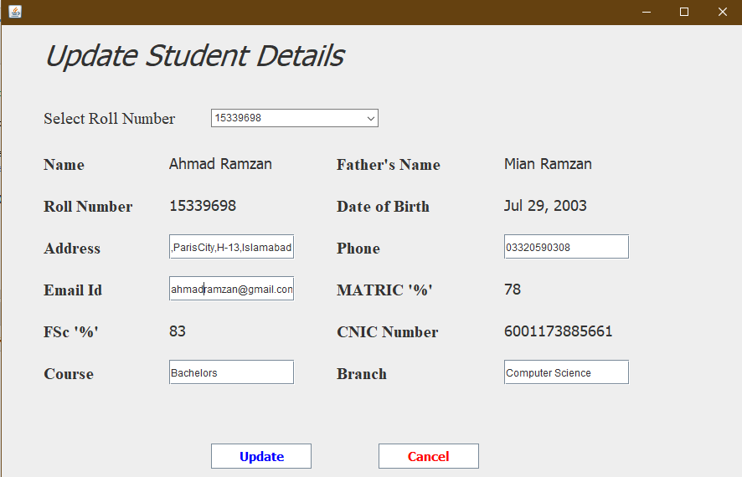

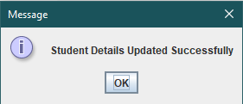

* **Program Code for UPDATE TEACHER DETAILS Window**



/*

* Click nbfs://nbhost/SystemFileSystem/Templates/Licenses/license-default.txt to change this license

* Click nbfs://nbhost/SystemFileSystem/Templates/Classes/Class.java to edit this template

*/

package college.management.system;

/**

*

* @author Muhammad Ahmad Sultan

*/

import javax.swing.*;

import java.awt.*;

import java.awt.event.*;

import java.sql.*;

public class UpdateTeacher extends JFrame implements ActionListener{

JTextField tfcourse, tfaddress, tfphone, tfemail, tfbranch;

JLabel labelEmpId;

JButton submit, cancel;

Choice cEmpId;

UpdateTeacher() {

setSize(900, 650);

setLocation(350, 50);

setLayout(null);

JLabel heading = new JLabel("Update Teacher Details");

heading.setBounds(50, 10, 500, 50);

heading.setFont(new Font("Tahoma", Font.ITALIC, 35));

add(heading);

JLabel lblrollnumber = new JLabel("Select Employee Id");

lblrollnumber.setBounds(50, 100, 200, 20);

lblrollnumber.setFont(new Font("serif", Font.PLAIN, 20));

add(lblrollnumber);

cEmpId = new Choice();

cEmpId.setBounds(250, 100, 200, 20);

add(cEmpId);

try {

dbConnectivity c = new dbConnectivity();

ResultSet rs = c.s.executeQuery("select * from teacher");

while(rs.next()) {

cEmpId.add(rs.getString("empId"));

}

} catch (Exception e) {

e.printStackTrace();

}

JLabel lblname = new JLabel("Name");

lblname.setBounds(50, 150, 100, 30);

lblname.setFont(new Font("serif", Font.BOLD, 20));

add(lblname);

JLabel labelname = new JLabel();

labelname.setBounds(200, 150, 150, 30);

labelname.setFont(new Font("Tahoma", Font.PLAIN, 18));

add(labelname);

JLabel lblfname = new JLabel("Father's Name");

lblfname.setBounds(400, 150, 200, 30);

lblfname.setFont(new Font("serif", Font.BOLD, 20));

add(lblfname);

JLabel labelfname = new JLabel();

labelfname.setBounds(600, 150, 150, 30);

labelfname.setFont(new Font("Tahoma", Font.PLAIN, 18));

add(labelfname);

JLabel lblrollno = new JLabel("Employee Id");

lblrollno.setBounds(50, 200, 200, 30);

lblrollno.setFont(new Font("serif", Font.BOLD, 20));

add(lblrollno);

labelEmpId = new JLabel();

labelEmpId.setBounds(200, 200, 200, 30);

labelEmpId.setFont(new Font("Tahoma", Font.PLAIN, 18));

add(labelEmpId);

JLabel lbldob = new JLabel("Date of Birth");

lbldob.setBounds(400, 200, 200, 30);

lbldob.setFont(new Font("serif", Font.BOLD, 20));

add(lbldob);

JLabel labeldob = new JLabel();

labeldob.setBounds(600, 200, 150, 30);

labeldob.setFont(new Font("Tahoma", Font.PLAIN, 18));

add(labeldob);

JLabel lbladdress = new JLabel("Address");

lbladdress.setBounds(50, 250, 200, 30);

lbladdress.setFont(new Font("serif", Font.BOLD, 20));

add(lbladdress);

tfaddress = new JTextField();

tfaddress.setBounds(200, 250, 150, 30);

add(tfaddress);

JLabel lblphone = new JLabel("Phone");

lblphone.setBounds(400, 250, 200, 30);

lblphone.setFont(new Font("serif", Font.BOLD, 20));

add(lblphone);

tfphone = new JTextField();

tfphone.setBounds(600, 250, 150, 30);

add(tfphone);

JLabel lblemail = new JLabel("Email Id");

lblemail.setBounds(50, 300, 200, 30);

lblemail.setFont(new Font("serif", Font.BOLD, 20));

add(lblemail);

tfemail = new JTextField();

tfemail.setBounds(200, 300, 150, 30);

add(tfemail);

JLabel lblx = new JLabel("MATRIC'%'");

lblx.setBounds(400, 300, 200, 30);

lblx.setFont(new Font("serif", Font.BOLD, 20));

add(lblx);

JLabel labelx = new JLabel();

labelx.setBounds(600, 300, 150, 30);

labelx.setFont(new Font("Tahoma", Font.PLAIN, 18));

add(labelx);

JLabel lblxii = new JLabel("FSc '%'");

lblxii.setBounds(50, 350, 200, 30);

lblxii.setFont(new Font("serif", Font.BOLD, 20));

add(lblxii);

JLabel labelxii = new JLabel();

labelxii.setBounds(200, 350, 150, 30);

labelxii.setFont(new Font("Tahoma", Font.PLAIN, 18));

add(labelxii);

JLabel lblcnic = new JLabel("CNIC Number");

lblcnic.setBounds(400, 350, 200, 30);

lblcnic.setFont(new Font("serif", Font.BOLD, 20));

add(lblcnic);

JLabel labelcnic = new JLabel();

labelcnic.setBounds(600, 350, 150, 30);

labelcnic.setFont(new Font("Tahoma", Font.PLAIN, 18));

add(labelcnic);

JLabel lblcourse = new JLabel("Education");

lblcourse.setBounds(50, 400, 200, 30);

lblcourse.setFont(new Font("serif", Font.BOLD, 20));

add(lblcourse);

tfcourse = new JTextField();

tfcourse.setBounds(200, 400, 150, 30);

add(tfcourse);

JLabel lblbranch = new JLabel("Department");

lblbranch.setBounds(400, 400, 200, 30);

lblbranch.setFont(new Font("serif", Font.BOLD, 20));

add(lblbranch);

tfbranch = new JTextField();

tfbranch.setBounds(600, 400, 150, 30);

add(tfbranch);

try {

dbConnectivity c = new dbConnectivity();

String query = "select * from teacher where empId='"+cEmpId.getSelectedItem()+"'";

ResultSet rs = c.s.executeQuery(query);

while(rs.next()) {

labelname.setText(rs.getString("name"));

labelfname.setText(rs.getString("fname"));

labeldob.setText(rs.getString("dob"));

tfaddress.setText(rs.getString("address"));

tfphone.setText(rs.getString("phone"));

tfemail.setText(rs.getString("email"));

labelx.setText(rs.getString("class_x"));

labelxii.setText(rs.getString("class_xii"));

labelcnic.setText(rs.getString("cnic"));

labelEmpId.setText(rs.getString("empId"));

tfcourse.setText(rs.getString("education"));

tfbranch.setText(rs.getString("department"));

}

} catch (Exception e) {

e.printStackTrace();

}

cEmpId.addItemListener(new ItemListener() {

public void itemStateChanged(ItemEvent ie) {

try {

dbConnectivity c = new dbConnectivity();

String query = "select * from teacher where empId='"+cEmpId.getSelectedItem()+"'";

ResultSet rs = c.s.executeQuery(query);

while(rs.next()) {

labelname.setText(rs.getString("name"));

labelfname.setText(rs.getString("fname"));

labeldob.setText(rs.getString("dob"));

tfaddress.setText(rs.getString("address"));

tfphone.setText(rs.getString("phone"));

tfemail.setText(rs.getString("email"));

labelx.setText(rs.getString("class_x"));

labelxii.setText(rs.getString("class_xii"));

labelcnic.setText(rs.getString("cnic"));

labelEmpId.setText(rs.getString("empId"));

tfcourse.setText(rs.getString("education"));

tfbranch.setText(rs.getString("department"));

}

} catch (Exception e) {

e.printStackTrace();

}

}

});

submit = new JButton("Update");

submit.setBounds(250, 500, 120, 30);

submit.setBackground(Color.WHITE);

submit.setForeground(Color.BLUE);

submit.addActionListener(this);

submit.setFont(new Font("Tahoma", Font.BOLD, 15));

add(submit);

cancel = new JButton("Cancel");

cancel.setBounds(450, 500, 120, 30);

cancel.setBackground(Color.WHITE);

cancel.setForeground(Color.RED);

cancel.addActionListener(this);

cancel.setFont(new Font("Tahoma", Font.BOLD, 15));

add(cancel);

setVisible(true);

}

public void actionPerformed(ActionEvent ae) {

if (ae.getSource() == submit) {

String empId = labelEmpId.getText();

String address = tfaddress.getText();

String phone = tfphone.getText();

String email = tfemail.getText();

String course = tfcourse.getText();

String branch = tfbranch.getText();

try {

String query = "update teacher set address='"+address+"', phone='"+phone+"', email='"+email+"', education='"+course+"', department='"+branch+"' where empId='"+empId+"'";

dbConnectivity con = new dbConnectivity();

con.s.executeUpdate(query);

JOptionPane.showMessageDialog(null, "Student Details Updated Successfully");

setVisible(false);

} catch (Exception e) {

e.printStackTrace();

}

} else {

setVisible(false);

}

}

public static void main(String[] args) {

new UpdateTeacher();

}

}

* **OUTPUT (ScreenShot) for UPDATE TEACHER Window**

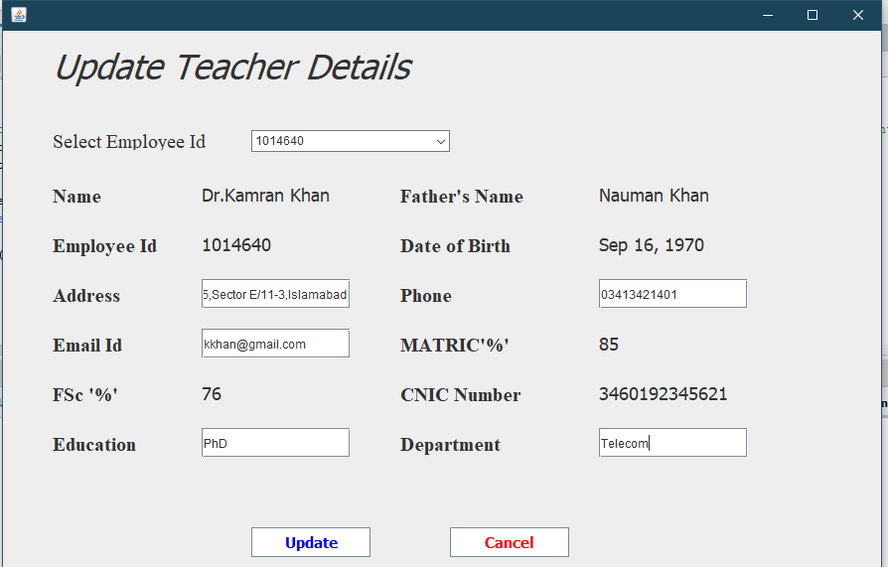

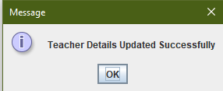

* **Program Code for FEE STRUCTURE Window**

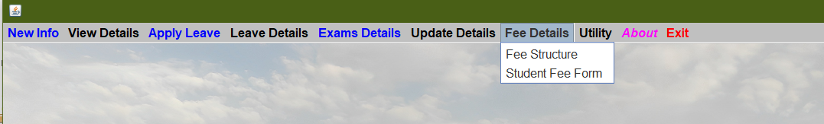

/*

* Click nbfs://nbhost/SystemFileSystem/Templates/Licenses/license-default.txt to change this license

* Click nbfs://nbhost/SystemFileSystem/Templates/Classes/Class.java to edit this template

*/

/**

*

* @author M Ahmad Sultan

*/

package college.management.system;

import javax.swing.*;

import java.awt.*;

import java.sql.*;

import net.proteanit.sql.DbUtils;

public class FeeStructure extends JFrame {

FeeStructure() {

setSize(1000, 700);

setLocation(250, 50);

setLayout(null);

getContentPane().setBackground(Color.WHITE);

JLabel heading = new JLabel("Fee Structure");

heading.setBounds(50, 10, 400, 30);

heading.setFont(new Font("Tahoma", Font.BOLD, 30));

add(heading);

JTable table = new JTable();

try {

dbConnectivity c = new dbConnectivity();

ResultSet rs = c.s.executeQuery("select * from fee_");

table.setModel(DbUtils.resultSetToTableModel(rs));

} catch (Exception e) {

e.printStackTrace();

}

JScrollPane jsp = new JScrollPane(table);

jsp.setBounds(0, 60, 1000, 700);

add(jsp);

setVisible(true);

}

public static void main(String[] args) {

new FeeStructure();

}

}

* **OUTPUT (ScreenShot) for FEE STRUCTURE Window**

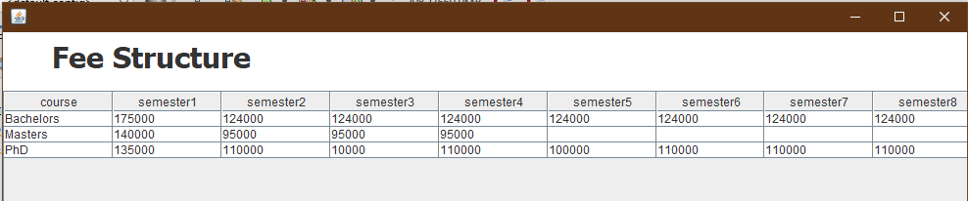

* **Program Code for STUDENT FEE FORM Window**



/*

* Click nbfs://nbhost/SystemFileSystem/Templates/Licenses/license-default.txt to change this license

* Click nbfs://nbhost/SystemFileSystem/Templates/Classes/Class.java to edit this template

*/

package college.management.system;

/**

*

* @author Muhammad Ahmad Sultan

*/

import javax.swing.*;

import java.awt.*;

import java.sql.*;

import java.awt.event.*;

public class StudentFeeForm extends JFrame implements ActionListener {

Choice rollno_;

JComboBox course_, branch_, semester_;

JLabel labeltotal;

JButton update, pay, back;

StudentFeeForm() {

setSize(900, 500);

setLocation(300, 100);

setLayout(null);

getContentPane().setBackground(Color.WHITE);

ImageIcon i1 = new ImageIcon(ClassLoader.getSystemResource("icons/fee@.jpg"));

Image i2 = i1.getImage().getScaledInstance(500, 300, Image.SCALE_DEFAULT);

ImageIcon i3 = new ImageIcon(i2);

JLabel image = new JLabel(i3);

image.setBounds(400, 50, 500, 300);

add(image);

JLabel lblrollnumber = new JLabel("Select Roll No");

lblrollnumber.setBounds(40, 60, 150, 20);

lblrollnumber.setFont(new Font("Tahoma", Font.BOLD, 16));

add(lblrollnumber);

rollno_ = new Choice();

rollno_.setBounds(200, 60, 150, 20);

add(rollno_);

try {

dbConnectivity c = new dbConnectivity();

ResultSet rs = c.s.executeQuery("select * from student");

while(rs.next()) {

rollno_.add(rs.getString("rollno"));

}

} catch (Exception e) {

e.printStackTrace();

}

JLabel lblname = new JLabel("Name");

lblname.setBounds(40, 100, 150, 20);

lblname.setFont(new Font("Tahoma", Font.BOLD, 16));

add(lblname);

JLabel labelname = new JLabel();

labelname.setBounds(200, 100, 150, 20);

labelname.setFont(new Font("Tahoma", Font.PLAIN, 16));

add(labelname);

JLabel lblfname = new JLabel("Father's Name");

lblfname.setBounds(40, 140, 150, 20);

lblfname.setFont(new Font("Tahoma", Font.BOLD, 16));

add(lblfname);

JLabel labelfname = new JLabel();

labelfname.setBounds(200, 140, 150, 20);

labelfname.setFont(new Font("Tahoma", Font.PLAIN, 16));

add(labelfname);

try {

dbConnectivity c = new dbConnectivity();

String query = "select * from student where rollno='"+rollno_.getSelectedItem()+"'";

ResultSet rs = c.s.executeQuery(query);

while(rs.next()) {

labelname.setText(rs.getString("name"));

labelfname.setText(rs.getString("fname"));

}

} catch (Exception e) {

e.printStackTrace();

}

rollno_.addItemListener(new ItemListener() {

public void itemStateChanged(ItemEvent ie) {

try {

dbConnectivity c = new dbConnectivity();

String query = "select * from student where rollno='"+rollno_.getSelectedItem()+"'";

ResultSet rs = c.s.executeQuery(query);

while(rs.next()) {

labelname.setText(rs.getString("name"));

labelfname.setText(rs.getString("fname"));

}

} catch (Exception e) {

e.printStackTrace();

}

}

});

JLabel lblcourse = new JLabel("Course");

lblcourse.setBounds(40, 180, 150, 20);

lblcourse.setFont(new Font("Tahoma", Font.BOLD, 16));

add(lblcourse);

String course[] = {"Bachelors", "Masters", "PhD"};

course_ = new JComboBox(course);

course_.setBounds(200, 180, 150, 20);

course_.setBackground(Color.WHITE);

add(course_);

JLabel lblbranch = new JLabel("Branch");

lblbranch.setBounds(40, 220, 150, 20);

lblbranch.setFont(new Font("Tahoma", Font.BOLD, 16));

add(lblbranch);

String branch[] = {"Software Engineering", "Computer Science", "Electrical Engineering", "Info Security", "Telecom"};

branch_ = new JComboBox(branch);

branch_.setBounds(200, 220, 150, 20);

branch_.setBackground(Color.WHITE);

add(branch_);

JLabel lblsemester = new JLabel("Semester");

lblsemester.setBounds(40, 260, 150, 20);

lblsemester.setFont(new Font("Tahoma", Font.BOLD, 16));

add(lblsemester);

String semester[] = {"Semester1", "Semester2", "Semester3", "Semester4", "Semester5", "Semester6", "Semester7", "Semester8" };

semester_ = new JComboBox(semester);

semester_.setBounds(200, 260, 150, 20);

semester_.setBackground(Color.WHITE);

add(semester_);

JLabel lbltotal = new JLabel("Total Payable");

lbltotal.setBounds(40, 300, 150, 20);

lbltotal.setFont(new Font("Tahoma", Font.BOLD, 16));

add(lbltotal);

labeltotal = new JLabel();

labeltotal.setBounds(200, 300, 150, 20);

labeltotal.setFont(new Font("Tahoma", Font.PLAIN, 16));

add(labeltotal);

update = new JButton("Update");

update.setBounds(30, 380, 100, 25);

update.setBackground(Color.BLACK);

update.setForeground(Color.GREEN);

update.addActionListener(this);

add(update);

pay = new JButton("Pay Fee");

pay.setBounds(150, 380, 100, 25);

pay.setBackground(Color.BLACK);

pay.setForeground(Color.YELLOW);

pay.addActionListener(this);

pay.setFont(new Font("Tahoma", Font.BOLD, 15));

add(pay);

back = new JButton("Back");

back.setBounds(270, 380, 100, 25);

back.setBackground(Color.BLACK);

back.setForeground(Color.RED);

back.addActionListener(this);

back.setFont(new Font("Tahoma", Font.BOLD, 15));

add(back);

setVisible(true);

}

public void actionPerformed(ActionEvent ae) {

if (ae.getSource() == update) {

String course = (String) course_.getSelectedItem();

String semester = (String) semester_.getSelectedItem();

try {

dbConnectivity c = new dbConnectivity();

ResultSet rs = c.s.executeQuery("select * from fee where course = '"+course+"'");

while(rs.next()) {

labeltotal.setText(rs.getString(semester));

}

} catch (Exception e) {

e.printStackTrace();

}

} else if (ae.getSource() == pay) {

String rollno = rollno_.getSelectedItem();

String course = (String) course_.getSelectedItem();

String semester = (String) semester_.getSelectedItem();

String branch = (String) branch_.getSelectedItem();

String total = labeltotal.getText();

try {

dbConnectivity c = new dbConnectivity();

String query = "insert into collegefee values('"+rollno+"', '"+course+"', '"+branch+"', '"+semester+"', '"+total+"')";

c.s.executeUpdate(query);

JOptionPane.showMessageDialog(null, "College fee submitted successfully");

setVisible(false);

} catch (Exception e) {

e.printStackTrace();

}

} else {

setVisible(false);

}

}

public static void main(String[] args) {

new StudentFeeForm();

}

}

* **OUTPUT (ScreenShot) for STUDENT FEE FORM Window**



* **Program Code for NOTEPAD Window**

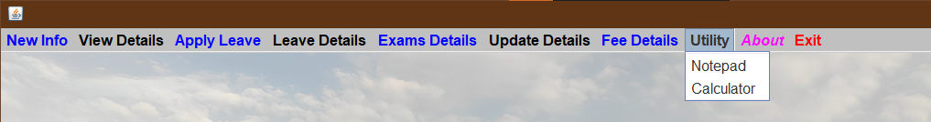

package college.management.system;

/**

*

* @author Muhammad Ahmad Sultan

*/

import javax.swing.*;

import java.awt.*;

import java.awt.event.*;

public class Project extends JFrame implements ActionListener {

Project() {

setSize(1300, 700);

ImageIcon i1 = new ImageIcon(ClassLoader.getSystemResource("icons/Nust.png"));

Image i2 = i1.getImage().getScaledInstance(1300, 700, Image.SCALE_DEFAULT);

ImageIcon i3 = new ImageIcon(i2);

JLabel image = new JLabel(i3);

add(image);

JMenuBar mb = new JMenuBar();

mb.setBackground(Color.LIGHT_GRAY);

// New Information

JMenu newInformation = new JMenu("New Info");

newInformation.setForeground(Color.BLUE);

newInformation.setFont(new Font("sansserif", Font.BOLD, 16));

mb.add(newInformation);

JMenuItem facultyInfo = new JMenuItem("New Faculty Information");

facultyInfo.setBackground(Color.WHITE);

facultyInfo.addActionListener(this);

facultyInfo.setFont(new Font("sansserif", Font.PLAIN, 16));

newInformation.add(facultyInfo);

JMenuItem studentInfo = new JMenuItem("New Student Information");

studentInfo.setBackground(Color.WHITE);

studentInfo.addActionListener(this);

studentInfo.setFont(new Font("sansserif", Font.PLAIN, 16));

newInformation.add(studentInfo);

// Details

JMenu details = new JMenu("View Details");

details.setForeground(Color.BLACK);

details.setFont(new Font("sansserif", Font.BOLD, 16));

mb.add(details);

JMenuItem facultydetails = new JMenuItem("View Faculty Details");

facultydetails.setBackground(Color.WHITE);

facultydetails.addActionListener(this);

facultydetails.setFont(new Font("sansserif", Font.PLAIN, 16));

details.add(facultydetails);

JMenuItem studentdetails = new JMenuItem("View Student Details");

studentdetails.setBackground(Color.WHITE);

studentdetails.addActionListener(this);

studentdetails.setFont(new Font("sansserif", Font.PLAIN, 16));

details.add(studentdetails);

// Leave

JMenu leave = new JMenu("Apply Leave");

leave.setForeground(Color.BLUE);

leave.setFont(new Font("sansserif", Font.BOLD, 16));

mb.add(leave);

JMenuItem facultyleave = new JMenuItem("Faculty Leave");

facultyleave.setBackground(Color.WHITE);

facultyleave.addActionListener(this);

facultyleave.setFont(new Font("sansserif", Font.PLAIN, 16));

leave.add(facultyleave);

JMenuItem studentleave = new JMenuItem("Student Leave");

studentleave.setBackground(Color.WHITE);

studentleave.addActionListener(this);

studentleave.setFont(new Font("sansserif", Font.PLAIN, 16));

leave.add(studentleave);

// Leave Details

JMenu leaveDetails = new JMenu("Leave Details");

leaveDetails.setForeground(Color.BLACK);

leaveDetails.setFont(new Font("sansserif", Font.BOLD, 16));

mb.add(leaveDetails);

JMenuItem facultyleavedetails = new JMenuItem("Faculty Leave Details");

facultyleavedetails.setBackground(Color.WHITE);

facultyleavedetails.addActionListener(this);

facultyleavedetails.setFont(new Font("sansserif", Font.PLAIN, 16));

leaveDetails.add(facultyleavedetails);

JMenuItem studentleavedetails = new JMenuItem("Student Leave Details");

studentleavedetails.setBackground(Color.WHITE);

studentleavedetails.addActionListener(this);

studentleavedetails.setFont(new Font("sansserif", Font.PLAIN, 16));

leaveDetails.add(studentleavedetails);

// Exams

JMenu exam = new JMenu("Exams Details");

exam.setForeground(Color.BLUE);

exam.setFont(new Font("sansserif", Font.BOLD, 16));

mb.add(exam);

JMenuItem examinationdetails = new JMenuItem("Examination Results");

examinationdetails.setBackground(Color.WHITE);

examinationdetails.addActionListener(this);

examinationdetails.setFont(new Font("sansserif", Font.PLAIN, 16));

exam.add(examinationdetails);

JMenuItem entermarks = new JMenuItem("Enter Marks");

entermarks.setBackground(Color.WHITE);

entermarks.addActionListener(this);

entermarks.setFont(new Font("sansserif", Font.PLAIN, 16));

exam.add(entermarks);

// UpdateInfo

JMenu updateInfo = new JMenu("Update Details");

updateInfo.setForeground(Color.BLACK);

updateInfo.setFont(new Font("sansserif", Font.BOLD, 16));

mb.add(updateInfo);

JMenuItem updatefacultyinfo = new JMenuItem("Update Faculty Details");

updatefacultyinfo.setBackground(Color.WHITE);

updatefacultyinfo.addActionListener(this);

updatefacultyinfo.setFont(new Font("sansserif", Font.PLAIN, 16));

updateInfo.add(updatefacultyinfo);

JMenuItem updatestudentinfo = new JMenuItem("Update Student Details");

updatestudentinfo.setBackground(Color.WHITE);

updatestudentinfo.addActionListener(this);

updatestudentinfo .setFont(new Font("sansserif", Font.PLAIN, 16));

updateInfo.add(updatestudentinfo);

// fee

JMenu fee = new JMenu("Fee Details");

fee.setForeground(Color.BLUE);

fee.setFont(new Font("sansserif", Font.BOLD, 16));

mb.add(fee);

JMenuItem feestructure = new JMenuItem("Fee Structure");

feestructure.setBackground(Color.WHITE);

feestructure.addActionListener(this);

feestructure .setFont(new Font("sansserif", Font.PLAIN, 16));

fee.add(feestructure);

JMenuItem feeform = new JMenuItem("Student Fee Form");

feeform.setBackground(Color.WHITE);

feeform.addActionListener(this);

feeform .setFont(new Font("sansserif", Font.PLAIN, 16));

fee.add(feeform);

// Utility

JMenu utility = new JMenu("Utility");

utility.setForeground(Color.BLACK);

utility.setFont(new Font("sansserif", Font.BOLD, 16));

mb.add(utility);

JMenuItem notepad = new JMenuItem("Notepad");

notepad.setBackground(Color.WHITE);

notepad.addActionListener(this);

notepad .setFont(new Font("sansserif", Font.PLAIN, 16));

utility.add(notepad);

JMenuItem calc = new JMenuItem("Calculator");

calc.setBackground(Color.WHITE);

calc.addActionListener(this);

calc.setFont(new Font("sansserif", Font.PLAIN, 16));

utility.add(calc);

// about

JMenu about = new JMenu("About");

about.setForeground(Color.MAGENTA);

about.setFont(new Font("sansserif", Font.BOLD|Font.ITALIC, 16));

mb.add(about);

JMenuItem ab = new JMenuItem("About");

ab.setBackground(Color.WHITE);

ab.addActionListener(this);

ab.setFont(new Font("sansserif", Font.PLAIN, 16));

about.add(ab);

// exit

JMenu exit = new JMenu("Exit");

exit.setForeground(Color.RED);

exit.setFont(new Font("sansserif", Font.BOLD, 16));

mb.add(exit);

JMenuItem ex = new JMenuItem("Exit");

ex.setBackground(Color.WHITE);

ex.addActionListener(this);

ex.setFont(new Font("sansserif", Font.PLAIN, 16));

exit.add(ex);

setJMenuBar(mb);

setVisible(true);

}

public void actionPerformed(ActionEvent ae) {

String msg = ae.getActionCommand();

if (msg.equals("Exit")) {

setVisible(false);

} else if (msg.equals("Calculator")) {

try {

Runtime.getRuntime().exec("calc.exe");

} catch (Exception e) {

}

} else if (msg.equals("Notepad")) {

try {

Runtime.getRuntime().exec("notepad.exe");

} catch (Exception e) {

}

} else if (msg.equals("New Faculty Information")) {

new AddTeacher();

} else if (msg.equals("New Student Information")) {

new AddStudent();

} else if (msg.equals("View Faculty Details")) {

new TeacherDetails();

} else if (msg.equals("View Student Details")) {

new StudentDetails();

} else if (msg.equals("Faculty Leave")) {

new TeacherLeave();

} else if (msg.equals("Student Leave")) {

new StudentLeave();

} else if (msg.equals("Faculty Leave Details")) {

new TeacherLeaveDetails();

} else if (msg.equals("Student Leave Details")) {

new StudentLeaveDetails();

} else if (msg.equals("Update Faculty Details")) {

new UpdateTeacher();

} else if (msg.equals("Update Student Details")) {

new UpdateStudent();

} else if (msg.equals("Enter Marks")) {

new EnterMarks();

} else if (msg.equals("Examination Results")) {

new ExaminationDetails();

} else if (msg.equals("Fee Structure")) {

new FeeStructure();

} else if (msg.equals("About")) {

new About();

} else if (msg.equals("Student Fee Form")) {

new StudentFeeForm();

}

}

public static void main(String[] args) {

new Project();

}

}

* **OUTPUT (ScreenShot) for NOTEPAD Window**

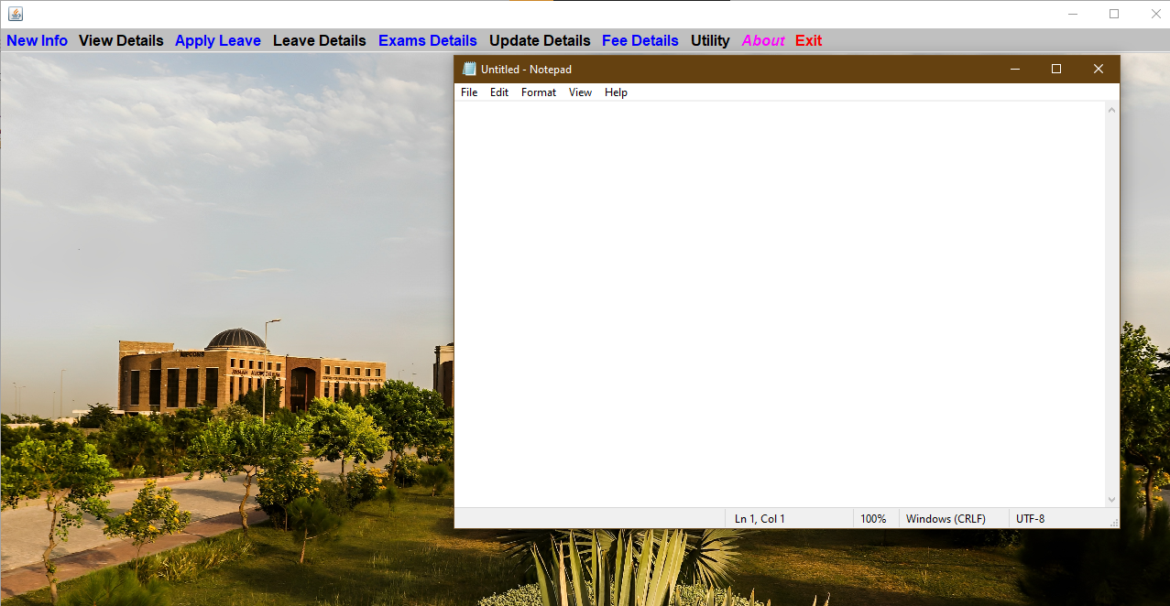

* **Program Code for CALCULATOR Window**



package college.management.system;

/**

*

* @author Muhammad Ahmad Sultan

*/

import javax.swing.*;

import java.awt.*;

import java.awt.event.*;

public class Project extends JFrame implements ActionListener {

Project() {

setSize(1300, 700);

ImageIcon i1 = new ImageIcon(ClassLoader.getSystemResource("icons/Nust.png"));

Image i2 = i1.getImage().getScaledInstance(1300, 700, Image.SCALE_DEFAULT);

ImageIcon i3 = new ImageIcon(i2);

JLabel image = new JLabel(i3);

add(image);

JMenuBar mb = new JMenuBar();

mb.setBackground(Color.LIGHT_GRAY);

// New Information

JMenu newInformation = new JMenu("New Info");

newInformation.setForeground(Color.BLUE);

newInformation.setFont(new Font("sansserif", Font.BOLD, 16));

mb.add(newInformation);

JMenuItem facultyInfo = new JMenuItem("New Faculty Information");

facultyInfo.setBackground(Color.WHITE);

facultyInfo.addActionListener(this);

facultyInfo.setFont(new Font("sansserif", Font.PLAIN, 16));

newInformation.add(facultyInfo);

JMenuItem studentInfo = new JMenuItem("New Student Information");

studentInfo.setBackground(Color.WHITE);

studentInfo.addActionListener(this);

studentInfo.setFont(new Font("sansserif", Font.PLAIN, 16));

newInformation.add(studentInfo);

// Details

JMenu details = new JMenu("View Details");

details.setForeground(Color.BLACK);

details.setFont(new Font("sansserif", Font.BOLD, 16));

mb.add(details);

JMenuItem facultydetails = new JMenuItem("View Faculty Details");

facultydetails.setBackground(Color.WHITE);

facultydetails.addActionListener(this);

facultydetails.setFont(new Font("sansserif", Font.PLAIN, 16));

details.add(facultydetails);

JMenuItem studentdetails = new JMenuItem("View Student Details");

studentdetails.setBackground(Color.WHITE);

studentdetails.addActionListener(this);

studentdetails.setFont(new Font("sansserif", Font.PLAIN, 16));

details.add(studentdetails);

// Leave

JMenu leave = new JMenu("Apply Leave");

leave.setForeground(Color.BLUE);

leave.setFont(new Font("sansserif", Font.BOLD, 16));

mb.add(leave);

JMenuItem facultyleave = new JMenuItem("Faculty Leave");

facultyleave.setBackground(Color.WHITE);

facultyleave.addActionListener(this);

facultyleave.setFont(new Font("sansserif", Font.PLAIN, 16));

leave.add(facultyleave);

JMenuItem studentleave = new JMenuItem("Student Leave");

studentleave.setBackground(Color.WHITE);

studentleave.addActionListener(this);

studentleave.setFont(new Font("sansserif", Font.PLAIN, 16));

leave.add(studentleave);

// Leave Details

JMenu leaveDetails = new JMenu("Leave Details");

leaveDetails.setForeground(Color.BLACK);

leaveDetails.setFont(new Font("sansserif", Font.BOLD, 16));

mb.add(leaveDetails);

JMenuItem facultyleavedetails = new JMenuItem("Faculty Leave Details");

facultyleavedetails.setBackground(Color.WHITE);

facultyleavedetails.addActionListener(this);

facultyleavedetails.setFont(new Font("sansserif", Font.PLAIN, 16));

leaveDetails.add(facultyleavedetails);

JMenuItem studentleavedetails = new JMenuItem("Student Leave Details");

studentleavedetails.setBackground(Color.WHITE);

studentleavedetails.addActionListener(this);

studentleavedetails.setFont(new Font("sansserif", Font.PLAIN, 16));

leaveDetails.add(studentleavedetails);

// Exams

JMenu exam = new JMenu("Exams Details");

exam.setForeground(Color.BLUE);

exam.setFont(new Font("sansserif", Font.BOLD, 16));

mb.add(exam);

JMenuItem examinationdetails = new JMenuItem("Examination Results");

examinationdetails.setBackground(Color.WHITE);

examinationdetails.addActionListener(this);

examinationdetails.setFont(new Font("sansserif", Font.PLAIN, 16));

exam.add(examinationdetails);

JMenuItem entermarks = new JMenuItem("Enter Marks");

entermarks.setBackground(Color.WHITE);

entermarks.addActionListener(this);

entermarks.setFont(new Font("sansserif", Font.PLAIN, 16));

exam.add(entermarks);

// UpdateInfo

JMenu updateInfo = new JMenu("Update Details");

updateInfo.setForeground(Color.BLACK);

updateInfo.setFont(new Font("sansserif", Font.BOLD, 16));

mb.add(updateInfo);

JMenuItem updatefacultyinfo = new JMenuItem("Update Faculty Details");

updatefacultyinfo.setBackground(Color.WHITE);

updatefacultyinfo.addActionListener(this);

updatefacultyinfo.setFont(new Font("sansserif", Font.PLAIN, 16));

updateInfo.add(updatefacultyinfo);

JMenuItem updatestudentinfo = new JMenuItem("Update Student Details");

updatestudentinfo.setBackground(Color.WHITE);

updatestudentinfo.addActionListener(this);

updatestudentinfo .setFont(new Font("sansserif", Font.PLAIN, 16));

updateInfo.add(updatestudentinfo);

// fee

JMenu fee = new JMenu("Fee Details");

fee.setForeground(Color.BLUE);

fee.setFont(new Font("sansserif", Font.BOLD, 16));

mb.add(fee);

JMenuItem feestructure = new JMenuItem("Fee Structure");

feestructure.setBackground(Color.WHITE);

feestructure.addActionListener(this);

feestructure .setFont(new Font("sansserif", Font.PLAIN, 16));

fee.add(feestructure);

JMenuItem feeform = new JMenuItem("Student Fee Form");

feeform.setBackground(Color.WHITE);

feeform.addActionListener(this);

feeform .setFont(new Font("sansserif", Font.PLAIN, 16));

fee.add(feeform);

// Utility

JMenu utility = new JMenu("Utility");

utility.setForeground(Color.BLACK);

utility.setFont(new Font("sansserif", Font.BOLD, 16));

mb.add(utility);

JMenuItem notepad = new JMenuItem("Notepad");

notepad.setBackground(Color.WHITE);

notepad.addActionListener(this);

notepad .setFont(new Font("sansserif", Font.PLAIN, 16));

utility.add(notepad);

JMenuItem calc = new JMenuItem("Calculator");

calc.setBackground(Color.WHITE);

calc.addActionListener(this);

calc.setFont(new Font("sansserif", Font.PLAIN, 16));

utility.add(calc);

// about

JMenu about = new JMenu("About");

about.setForeground(Color.MAGENTA);

about.setFont(new Font("sansserif", Font.BOLD|Font.ITALIC, 16));

mb.add(about);

JMenuItem ab = new JMenuItem("About");

ab.setBackground(Color.WHITE);

ab.addActionListener(this);

ab.setFont(new Font("sansserif", Font.PLAIN, 16));

about.add(ab);

// exit

JMenu exit = new JMenu("Exit");

exit.setForeground(Color.RED);

exit.setFont(new Font("sansserif", Font.BOLD, 16));

mb.add(exit);

JMenuItem ex = new JMenuItem("Exit");

ex.setBackground(Color.WHITE);

ex.addActionListener(this);

ex.setFont(new Font("sansserif", Font.PLAIN, 16));

exit.add(ex);

setJMenuBar(mb);

setVisible(true);

}

public void actionPerformed(ActionEvent ae) {

String msg = ae.getActionCommand();

if (msg.equals("Exit")) {

setVisible(false);

} else if (msg.equals("Calculator")) {

try {

Runtime.getRuntime().exec("calc.exe");

} catch (Exception e) {

}

} else if (msg.equals("Notepad")) {

try {

Runtime.getRuntime().exec("notepad.exe");

} catch (Exception e) {

}

} else if (msg.equals("New Faculty Information")) {

new AddTeacher();

} else if (msg.equals("New Student Information")) {

new AddStudent();

} else if (msg.equals("View Faculty Details")) {

new TeacherDetails();

} else if (msg.equals("View Student Details")) {

new StudentDetails();

} else if (msg.equals("Faculty Leave")) {

new TeacherLeave();

} else if (msg.equals("Student Leave")) {

new StudentLeave();

} else if (msg.equals("Faculty Leave Details")) {

new TeacherLeaveDetails();

} else if (msg.equals("Student Leave Details")) {

new StudentLeaveDetails();

} else if (msg.equals("Update Faculty Details")) {

new UpdateTeacher();

} else if (msg.equals("Update Student Details")) {

new UpdateStudent();

} else if (msg.equals("Enter Marks")) {

new EnterMarks();

} else if (msg.equals("Examination Results")) {

new ExaminationDetails();

} else if (msg.equals("Fee Structure")) {

new FeeStructure();

} else if (msg.equals("About")) {

new About();

} else if (msg.equals("Student Fee Form")) {

new StudentFeeForm();

}

}

public static void main(String[] args) {

new Project();

}

}

* **OUTPUT (ScreenShot) for CALCULATOR Window**

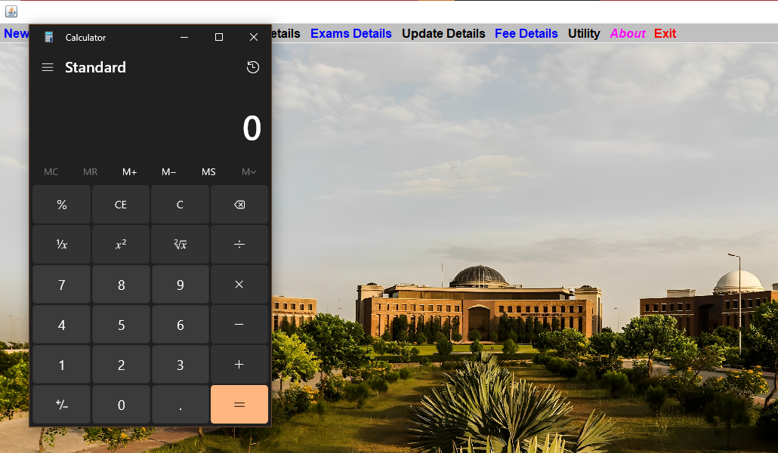

* **Program Code for ABOUT DEV Window**

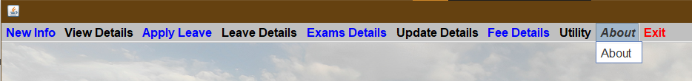

/*

* Click nbfs://nbhost/SystemFileSystem/Templates/Licenses/license-default.txt to change this license

* Click nbfs://nbhost/SystemFileSystem/Templates/Classes/Class.java to edit this template

*/

/**

*

* @author Muhammad Ahmad Sultan

*/

package college.management.system;

import javax.swing.*;

import java.awt.*;

public class About extends JFrame {

About() {

setSize(700, 840);

setLocation(350, 5);

getContentPane().setBackground(Color.WHITE);

// Top left logo

ImageIcon logo1 = new ImageIcon(ClassLoader.getSystemResource("icons/nustlogo.png"));

Image logo1Scaled = logo1.getImage().getScaledInstance(100, 100, Image.SCALE_DEFAULT);

ImageIcon logo1Icon = new ImageIcon(logo1Scaled);

JLabel logo1Label = new JLabel(logo1Icon);

logo1Label.setBounds(10, 10, 100, 100);

add(logo1Label);

// Top right logo

ImageIcon logo2 = new ImageIcon(ClassLoader.getSystemResource("icons/mcs.png"));

Image logo2Scaled = logo2.getImage().getScaledInstance(100, 100, Image.SCALE_DEFAULT);

ImageIcon logo2Icon = new ImageIcon(logo2Scaled);

JLabel logo2Label = new JLabel(logo2Icon);

logo2Label.setBounds(580, 10, 100, 100);

add(logo2Label);

// Main heading

JLabel heading = new JLabel("<html><div style='text-align: center;'>Miltary College of Signals<br/>Department of Software Engineering</div></html>");

heading.setBounds(100, 0, 500, 250);

heading.setFont(new Font("serif", Font.BOLD|Font.ITALIC, 32));

heading.setForeground(Color.RED);

add(heading);

// Second heading

JLabel heading_ = new JLabel("<html><div style='text-align: center;'>Student Management System</div></html>");

heading_.setBounds(120, 100, 500, 200);

heading_.setFont(new Font("sansserif", Font.BOLD, 34));

heading_.setForeground(Color.BLUE);

add(heading_);

// Developer name

JLabel name = new JLabel("<html><div style='text-align: center;'>Developed By:<br/>MUHAMMAD AHMAD SULTAN</div></html>");

name.setBounds(140, 230, 500, 80);

name.setFont(new Font("Tahoma", Font.BOLD|Font.ITALIC, 28));

name.setForeground(Color.BLACK);

add(name);

// Developer picture

ImageIcon devPic = new ImageIcon(ClassLoader.getSystemResource("icons/myPic.png"));

Image devPicScaled = devPic.getImage().getScaledInstance(220, 220, Image.SCALE_DEFAULT);

ImageIcon devPicIcon = new ImageIcon(devPicScaled);

JLabel devPicLabel = new JLabel(devPicIcon);

devPicLabel.setBounds(250, 320, 220, 220);

add(devPicLabel);

// CMS ID Number

JLabel rollno = new JLabel("<html><div style='text-align: center;'>CMS ID # : 408709</div></html>");

rollno.setBounds(250, 520, 500, 80);

rollno.setFont(new Font("Tahoma", Font.BOLD|Font.ITALIC, 22));

rollno.setForeground(Color.DARK_GRAY);

add(rollno);

// Batch

JLabel batch = new JLabel("<html><div style='text-align: center;'> Batch: BESE-28 (C) </div></html>");

batch.setBounds(250, 550, 500, 80);

batch.setFont(new Font("Tahoma", Font.BOLD|Font.ITALIC, 22));

batch.setForeground(Color. ORANGE);

add(batch);

// Contact details

JLabel contact = new JLabel("<html><div style='text-align: center;'>Contact Info <br/>Email : m.ahmadsultan123mas@gmail.com<br/>Phone :+92 306 1611301</div></html>");

contact.setBounds(140, 600, 500, 100);

contact.setFont(new Font("Tahoma", Font.ITALIC, 22));

contact.setForeground(Color.BLACK);

add(contact);

setLayout(null);

setVisible(true);

}

public static void main(String[] args) {

new About();

}

}

* **OUTPUT (ScreenShot) for ABOUT DEV Window**



* **Program Code for EXIT Window**

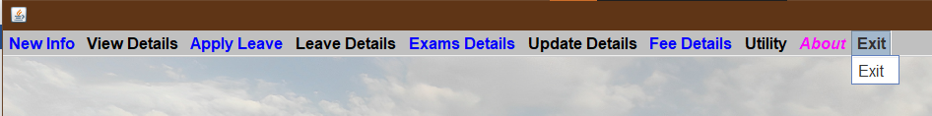

package college.management.system;

/**

*

* @author Muhammad Ahmad Sultan

*/

import javax.swing.*;

import java.awt.*;

import java.awt.event.*;

public class Project extends JFrame implements ActionListener {

Project() {

setSize(1300, 700);

ImageIcon i1 = new ImageIcon(ClassLoader.getSystemResource("icons/Nust.png"));

Image i2 = i1.getImage().getScaledInstance(1300, 700, Image.SCALE_DEFAULT);

ImageIcon i3 = new ImageIcon(i2);

JLabel image = new JLabel(i3);

add(image);

JMenuBar mb = new JMenuBar();

mb.setBackground(Color.LIGHT_GRAY);

// New Information

JMenu newInformation = new JMenu("New Info");

newInformation.setForeground(Color.BLUE);

newInformation.setFont(new Font("sansserif", Font.BOLD, 16));

mb.add(newInformation);

JMenuItem facultyInfo = new JMenuItem("New Faculty Information");

facultyInfo.setBackground(Color.WHITE);

facultyInfo.addActionListener(this);

facultyInfo.setFont(new Font("sansserif", Font.PLAIN, 16));

newInformation.add(facultyInfo);

JMenuItem studentInfo = new JMenuItem("New Student Information");

studentInfo.setBackground(Color.WHITE);

studentInfo.addActionListener(this);

studentInfo.setFont(new Font("sansserif", Font.PLAIN, 16));

newInformation.add(studentInfo);

// Details

JMenu details = new JMenu("View Details");

details.setForeground(Color.BLACK);

details.setFont(new Font("sansserif", Font.BOLD, 16));

mb.add(details);

JMenuItem facultydetails = new JMenuItem("View Faculty Details");

facultydetails.setBackground(Color.WHITE);

facultydetails.addActionListener(this);

facultydetails.setFont(new Font("sansserif", Font.PLAIN, 16));

details.add(facultydetails);

JMenuItem studentdetails = new JMenuItem("View Student Details");

studentdetails.setBackground(Color.WHITE);

studentdetails.addActionListener(this);

studentdetails.setFont(new Font("sansserif", Font.PLAIN, 16));

details.add(studentdetails);

// Leave

JMenu leave = new JMenu("Apply Leave");

leave.setForeground(Color.BLUE);

leave.setFont(new Font("sansserif", Font.BOLD, 16));

mb.add(leave);

JMenuItem facultyleave = new JMenuItem("Faculty Leave");

facultyleave.setBackground(Color.WHITE);

facultyleave.addActionListener(this);

facultyleave.setFont(new Font("sansserif", Font.PLAIN, 16));

leave.add(facultyleave);

JMenuItem studentleave = new JMenuItem("Student Leave");

studentleave.setBackground(Color.WHITE);

studentleave.addActionListener(this);

studentleave.setFont(new Font("sansserif", Font.PLAIN, 16));

leave.add(studentleave);

// Leave Details

JMenu leaveDetails = new JMenu("Leave Details");

leaveDetails.setForeground(Color.BLACK);

leaveDetails.setFont(new Font("sansserif", Font.BOLD, 16));

mb.add(leaveDetails);

JMenuItem facultyleavedetails = new JMenuItem("Faculty Leave Details");

facultyleavedetails.setBackground(Color.WHITE);

facultyleavedetails.addActionListener(this);

facultyleavedetails.setFont(new Font("sansserif", Font.PLAIN, 16));

leaveDetails.add(facultyleavedetails);

JMenuItem studentleavedetails = new JMenuItem("Student Leave Details");

studentleavedetails.setBackground(Color.WHITE);

studentleavedetails.addActionListener(this);

studentleavedetails.setFont(new Font("sansserif", Font.PLAIN, 16));

leaveDetails.add(studentleavedetails);

// Exams

JMenu exam = new JMenu("Exams Details");

exam.setForeground(Color.BLUE);

exam.setFont(new Font("sansserif", Font.BOLD, 16));

mb.add(exam);

JMenuItem examinationdetails = new JMenuItem("Examination Results");

examinationdetails.setBackground(Color.WHITE);

examinationdetails.addActionListener(this);

examinationdetails.setFont(new Font("sansserif", Font.PLAIN, 16));

exam.add(examinationdetails);

JMenuItem entermarks = new JMenuItem("Enter Marks");

entermarks.setBackground(Color.WHITE);

entermarks.addActionListener(this);

entermarks.setFont(new Font("sansserif", Font.PLAIN, 16));

exam.add(entermarks);

// UpdateInfo

JMenu updateInfo = new JMenu("Update Details");

updateInfo.setForeground(Color.BLACK);

updateInfo.setFont(new Font("sansserif", Font.BOLD, 16));

mb.add(updateInfo);

JMenuItem updatefacultyinfo = new JMenuItem("Update Faculty Details");

updatefacultyinfo.setBackground(Color.WHITE);

updatefacultyinfo.addActionListener(this);

updatefacultyinfo.setFont(new Font("sansserif", Font.PLAIN, 16));

updateInfo.add(updatefacultyinfo);

JMenuItem updatestudentinfo = new JMenuItem("Update Student Details");

updatestudentinfo.setBackground(Color.WHITE);

updatestudentinfo.addActionListener(this);

updatestudentinfo .setFont(new Font("sansserif", Font.PLAIN, 16));

updateInfo.add(updatestudentinfo);

// fee

JMenu fee = new JMenu("Fee Details");

fee.setForeground(Color.BLUE);

fee.setFont(new Font("sansserif", Font.BOLD, 16));

mb.add(fee);

JMenuItem feestructure = new JMenuItem("Fee Structure");

feestructure.setBackground(Color.WHITE);

feestructure.addActionListener(this);

feestructure .setFont(new Font("sansserif", Font.PLAIN, 16));

fee.add(feestructure);

JMenuItem feeform = new JMenuItem("Student Fee Form");

feeform.setBackground(Color.WHITE);

feeform.addActionListener(this);

feeform .setFont(new Font("sansserif", Font.PLAIN, 16));

fee.add(feeform);

// Utility

JMenu utility = new JMenu("Utility");

utility.setForeground(Color.BLACK);

utility.setFont(new Font("sansserif", Font.BOLD, 16));

mb.add(utility);

JMenuItem notepad = new JMenuItem("Notepad");

notepad.setBackground(Color.WHITE);

notepad.addActionListener(this);

notepad .setFont(new Font("sansserif", Font.PLAIN, 16));

utility.add(notepad);

JMenuItem calc = new JMenuItem("Calculator");

calc.setBackground(Color.WHITE);

calc.addActionListener(this);

calc.setFont(new Font("sansserif", Font.PLAIN, 16));

utility.add(calc);

// about

JMenu about = new JMenu("About");

about.setForeground(Color.MAGENTA);

about.setFont(new Font("sansserif", Font.BOLD|Font.ITALIC, 16));

mb.add(about);

JMenuItem ab = new JMenuItem("About");

ab.setBackground(Color.WHITE);

ab.addActionListener(this);

ab.setFont(new Font("sansserif", Font.PLAIN, 16));

about.add(ab);

// exit

JMenu exit = new JMenu("Exit");

exit.setForeground(Color.RED);

exit.setFont(new Font("sansserif", Font.BOLD, 16));

mb.add(exit);

JMenuItem ex = new JMenuItem("Exit");

ex.setBackground(Color.WHITE);

ex.addActionListener(this);

ex.setFont(new Font("sansserif", Font.PLAIN, 16));

exit.add(ex);

setJMenuBar(mb);

setVisible(true);

}

public void actionPerformed(ActionEvent ae) {

String msg = ae.getActionCommand();

if (msg.equals("Exit")) {

setVisible(false);

} else if (msg.equals("Calculator")) {

try {

Runtime.getRuntime().exec("calc.exe");

} catch (Exception e) {

}

} else if (msg.equals("Notepad")) {

try {

Runtime.getRuntime().exec("notepad.exe");

} catch (Exception e) {

}

} else if (msg.equals("New Faculty Information")) {

new AddTeacher();

} else if (msg.equals("New Student Information")) {

new AddStudent();

} else if (msg.equals("View Faculty Details")) {

new TeacherDetails();

} else if (msg.equals("View Student Details")) {

new StudentDetails();

} else if (msg.equals("Faculty Leave")) {

new TeacherLeave();

} else if (msg.equals("Student Leave")) {

new StudentLeave();

} else if (msg.equals("Faculty Leave Details")) {

new TeacherLeaveDetails();

} else if (msg.equals("Student Leave Details")) {

new StudentLeaveDetails();

} else if (msg.equals("Update Faculty Details")) {

new UpdateTeacher();

} else if (msg.equals("Update Student Details")) {

new UpdateStudent();

} else if (msg.equals("Enter Marks")) {

new EnterMarks();

} else if (msg.equals("Examination Results")) {

new ExaminationDetails();

} else if (msg.equals("Fee Structure")) {

new FeeStructure();

} else if (msg.equals("About")) {

new About();

} else if (msg.equals("Student Fee Form")) {

new StudentFeeForm();

}

}

public static void main(String[] args) {

new Project();

}

}

* **OUTPUT (ScreenShot) for EXIT Window**

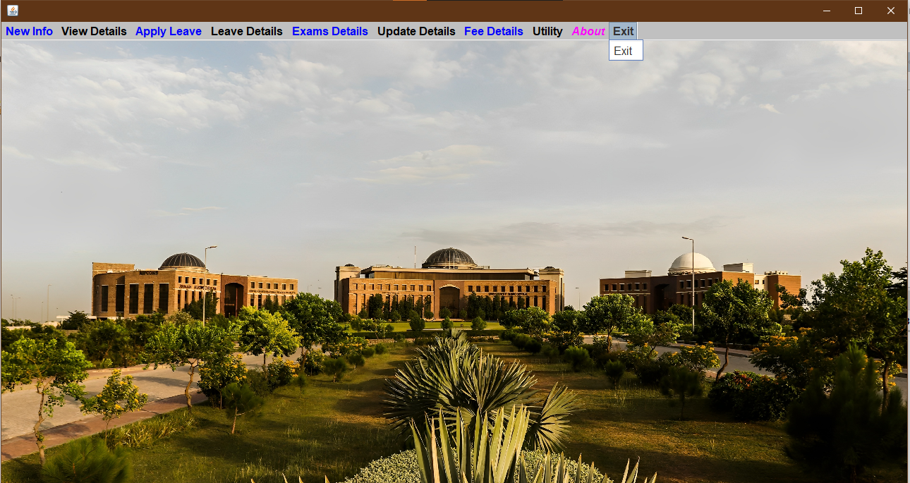

* **Program Code for DATABASE mySQL CONNECTIVITYWindow**

package college.management.system;

/**

*

* @author Muhammad Ahmad Sultan

*/

import java.sql.*;

public class dbConnectivity {

Connection c;

Statement s;

dbConnectivity () {

try {

Class.forName("com.mysql.cj.jdbc.Driver");

c = DriverManager.getConnection("jdbc:mysql://localhost:3306/collegemanagementsystem","root","mcs@123789");

s = c.createStatement();

} catch (Exception e) {

e.printStackTrace();

}

}

}

* 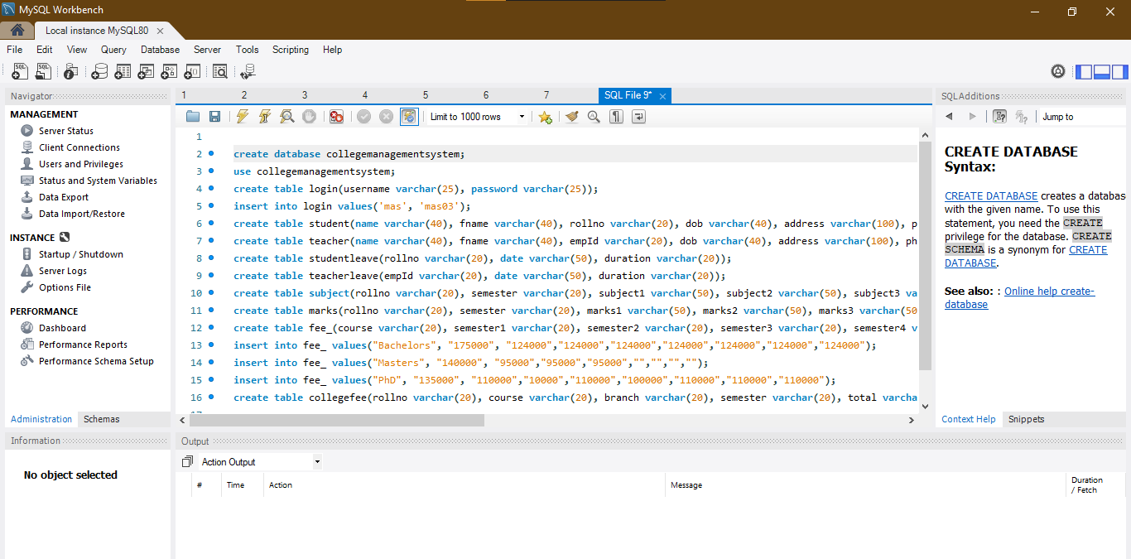**OUTPUT (ScreenShot) for DATABASE mySQL CONNECTIVITY Window**
* Signature of the student:
* Name of the Instructor: LE Muhammad Asif
* Signature of the Instructor :

**THE END**